**Table of Contents**

Creating The Database: 3

ERD Diagram: 8

Inserting Data: 8

Populating Tables: 18

Creating 3 queries: 23

Query 1 23

Query 2 24

Query 3 26

Create Audit 28

Trigger: AFTER INSERT 28

Trigger: AFTER UPDATE 29

Trigger: AFTER DELETE 30

Testing the Operations 31

Stored Procedure (SP): 35

User Defined Function (UDF): 38

Create and Use a Cursor: 41

# **Creating Database:**

CREATE DATABASE Group_35;

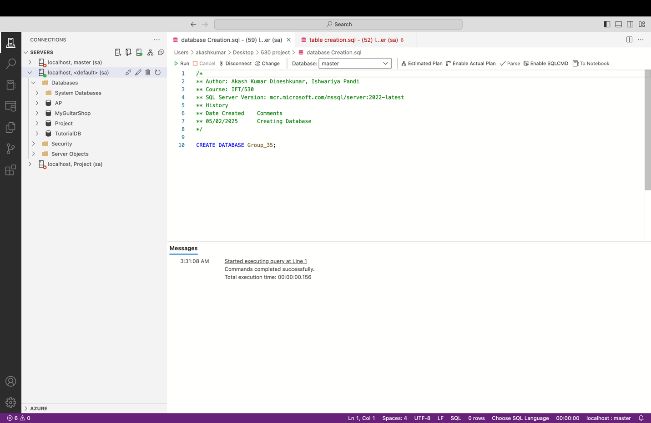

**Creating Tables:**

CREATE TABLE List_of_Players (

Player VARCHAR(100) NOT NULL PRIMARY KEY,

Birth_date DATE NOT NULL,

Team VARCHAR(50) NOT NULL,

Batting_style VARCHAR(50) NOT NULL,

Bowling_style VARCHAR(50),

FOREIGN KEY (Player) REFERENCES List_of_Players(Player)

);

CREATE TABLE Total_Run_of_the_Players (

Player VARCHAR(100) NOT NULL,

Team VARCHAR(50) NOT NULL,

Mat INT NOT NULL,

Inns INT NOT NULL CHECK (Inns >= 0),

NO INT NOT NULL,

Runs INT NOT NULL,

HS VARCHAR(10) NOT NULL,

Ave FLOAT NOT NULL,

BF INT NOT NULL,

SR FLOAT NOT NULL,

"100" INT NOT NULL,

"50" INT NOT NULL,

"4s" INT NOT NULL,

"6s" INT NOT NULL,

FOREIGN KEY (Player) REFERENCES List_of_Players(Player)

);

CREATE TABLE Best_Bowling (

Player VARCHAR(100) NOT NULL,

Team VARCHAR(50) NOT NULL,

Mat INT NOT NULL,

Inns INT NOT NULL,

Balls INT NOT NULL,

Overs FLOAT NOT NULL,

Mdns INT NOT NULL,

Runs INT NOT NULL,

Wkts INT NOT NULL CHECK (Wkts >= 0),

BBI VARCHAR(20) NOT NULL,

Ave FLOAT NOT NULL,

Econ FLOAT NOT NULL,

SR FLOAT NOT NULL,

"4" INT NOT NULL,

"5" INT NOT NULL,

FOREIGN KEY (Player) REFERENCES List_of_Players(Player)

);

CREATE TABLE Best_Batting (

Player VARCHAR(100) NOT NULL,

Runs VARCHAR(10) NOT NULL CHECK (CAST(Runs AS INT) >= 0),

Mins INT NOT NULL,

Balls INT NOT NULL,

"4s" INT NOT NULL,

"6s" INT NOT NULL,

SR FLOAT NOT NULL,

Team VARCHAR(50) NOT NULL,

Opposition VARCHAR(50) NOT NULL,

Ground VARCHAR(50) NOT NULL ,

Match_Date DATE NOT NULL PRIMARY KEY,

FOREIGN KEY (Player) REFERENCES List_of_Players(Player)

);

CREATE TABLE Player_Summary (

Player VARCHAR(100) NOT NULL,

Team VARCHAR(50) NOT NULL,

Batting_style VARCHAR(50) NOT NULL,

Bowling_style VARCHAR(50),

Runs VARCHAR(10),

Batting_Avg VARCHAR(10),

Batting_SR VARCHAR(10),

Wickets VARCHAR(10),

Bowling_Avg VARCHAR(10),

Economy VARCHAR(10),

Bowling_SR VARCHAR(10),

FOREIGN KEY (Player) REFERENCES List_of_Players(Player)

);

CREATE TABLE T20_2024_Summary (

Match_ID INT NOT NULL,

Team_1 VARCHAR(50) NOT NULL,

Team_2 VARCHAR(50) NOT NULL,

Winner VARCHAR(50) NOT NULL,

Margin VARCHAR(20) NOT NULL,

Ground VARCHAR(50) NOT NULL,

Match_Date DATE NOT NULL,

FOREIGN KEY (Match_Date) REFERENCES Best_Batting(Match_Date)

);

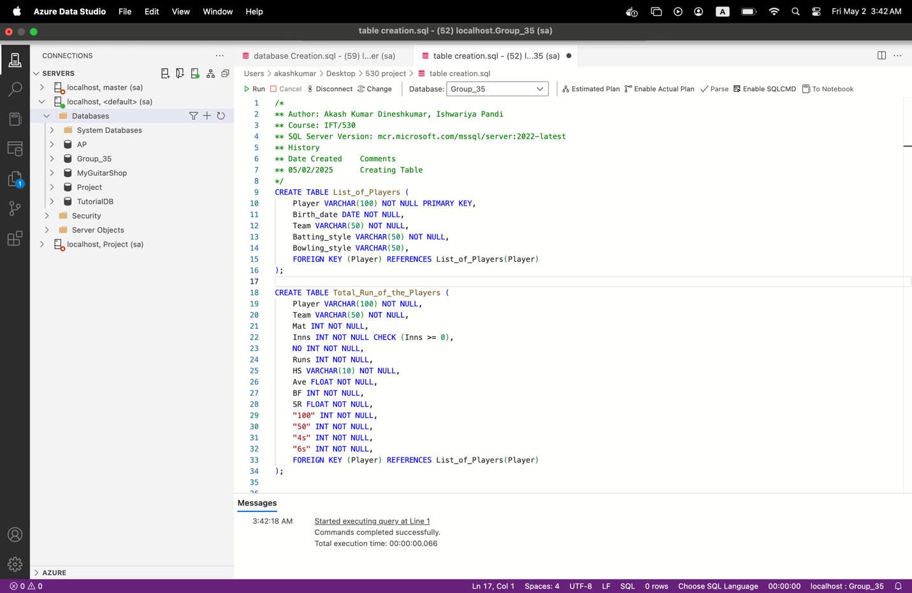

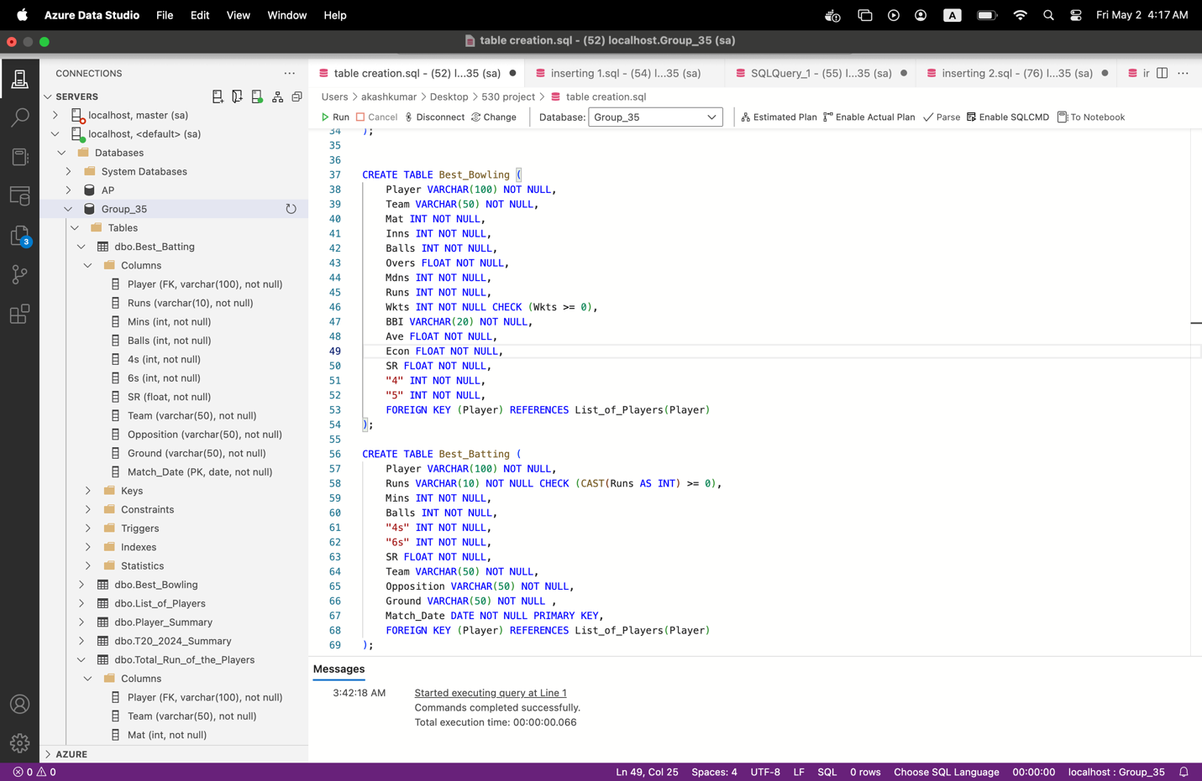

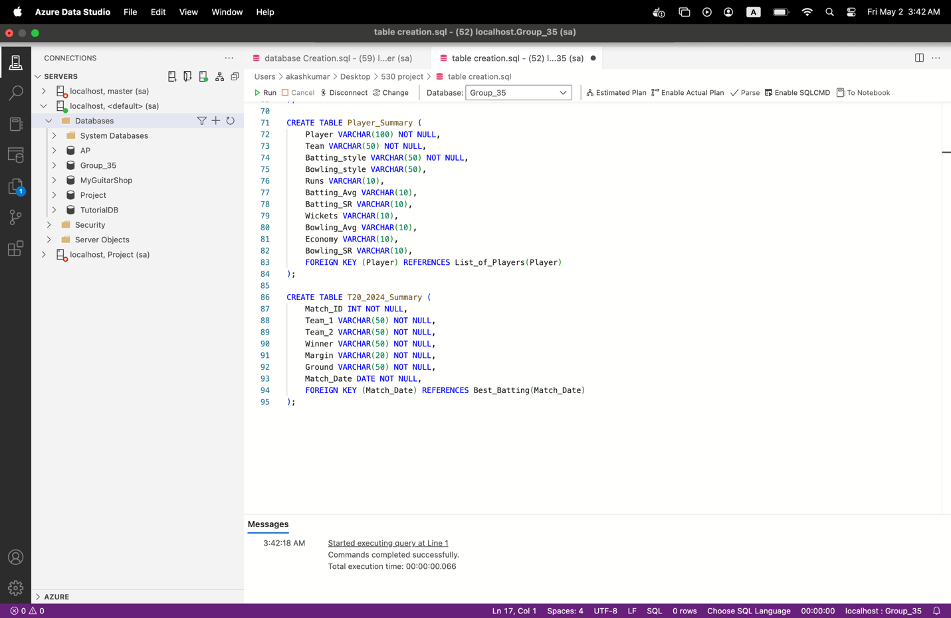

# **ERD Diagram:**

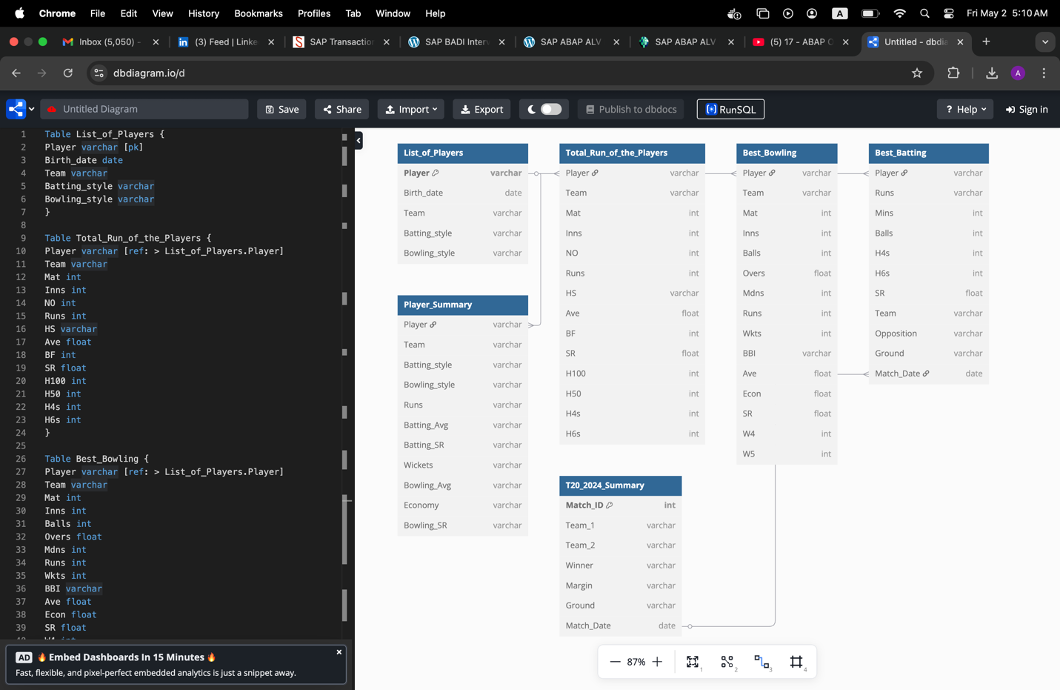

**Inserting data:**

T20_2024_Summary:

INSERT INTO T20_2024_Summary (Match_ID, Team_1, Team_2, Winner, Margin, Ground, Match_Date)

VALUES

(1, 'India', 'Pakistan', 'India', '10 runs', 'Eden Gardens', '2024-06-01'),

(2, 'Pakistan', 'India', 'Pakistan', '5 wickets', 'Eden Gardens', '2024-06-03'),

(3, 'Australia', 'England', 'Australia', '7 wickets', 'MCG', '2024-06-02'),

(4, 'England', 'Australia', 'Australia', '8 runs', 'MCG', '2024-06-07'),

(5, 'Australia', 'Bangladesh', 'Australia', '5 wickets', 'Gabba', '2024-06-06'),

(6, 'Afghanistan', 'Bangladesh', 'Afghanistan', '4 wickets', 'Sher-e-Bangla', '2024-06-08'),

(7, 'India', 'New Zealand', 'India', '6 wickets', 'Wankhede', '2024-06-04'),

(8, 'England', 'Pakistan', 'England', '3 wickets', 'Oval', '2024-06-05'),

(9, 'Bangladesh', 'India', 'India', '4 wickets', 'Hyderabad', '2024-06-11'),

(10, 'New Zealand', 'Bangladesh', 'New Zealand', '7 wickets', 'Hamilton', '2024-06-20'),

(11, 'India', 'Afghanistan', 'India', '8 wickets', 'Ahmedabad', '2024-06-18'),

(12, 'Pakistan', 'England', 'Pakistan', '5 runs', 'Oval', '2024-06-13'),

(13, 'Australia', 'Afghanistan', 'Australia', '6 wickets', 'SCG', '2024-06-10'),

(14, 'England', 'Afghanistan', 'England', '4 wickets', 'Lords', '2024-06-12'),

(15, 'Bangladesh', 'Afghanistan', 'Afghanistan', '5 wickets', 'Sher-e-Bangla', '2024-06-23'),

(16, 'Afghanistan', 'Pakistan', 'Afghanistan', '2 wickets', 'Karachi', '2024-06-16'),

(17, 'New Zealand', 'Bangladesh', 'New Zealand', '7 wickets', 'Hamilton', '2024-06-22'),

(18, 'South Africa', 'Australia', 'South Africa', '5 wickets', 'Adelaide', '2024-06-15'),

(19, 'South Africa', 'India', 'South Africa', '9 runs', 'Wankhede', '2024-06-14'),

(20, 'Pakistan', 'Afghanistan', 'Pakistan', '8 wickets', 'Karachi', '2024-06-17');

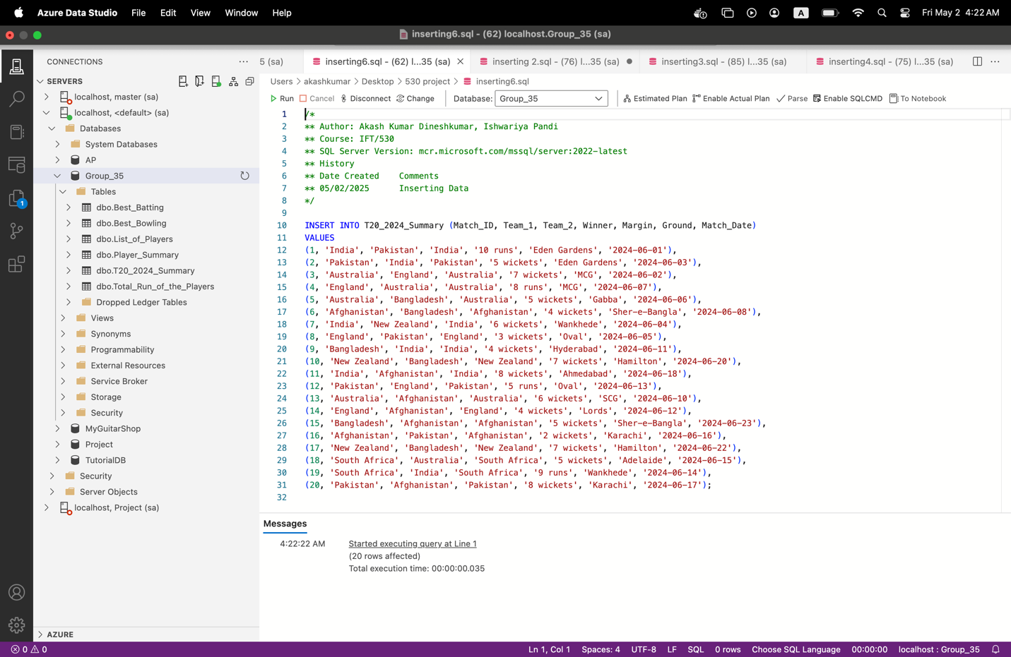

**List_of_Players**

INSERT INTO List_of_Players (Player, Birth_date, Team, Batting_style, Bowling_style)

VALUES

('Virat Kohli', '1988-11-05', 'India', 'Right-hand bat', NULL),

('Babar Azam', '1994-10-15', 'Pakistan', 'Right-hand bat', NULL),

('David Warner', '1986-10-27', 'Australia', 'Left-hand bat', NULL),

('Joe Root', '1990-12-30', 'England', 'Right-hand bat', 'Offbreak'),

('Glenn Maxwell', '1988-10-14', 'Australia', 'Right-hand bat', 'Offbreak'),

('Rashid Khan', '1998-09-20', 'Afghanistan', 'Right-hand bat', 'Legbreak googly'),

('Jasprit Bumrah', '1993-12-06', 'India', 'Right-hand bat', 'Right-arm fast'),

('Ben Stokes', '1991-06-04', 'England', 'Left-hand bat', 'Right-arm medium'),

('Shakib Al Hasan', '1987-03-24', 'Bangladesh', 'Left-hand bat', 'Slow left-arm orthodox'),

('Trent Boult', '1989-07-22', 'New Zealand', 'Right-hand bat', 'Left-arm fast'),

('KL Rahul', '1992-04-18', 'India', 'Right-hand bat', NULL),

('Mohammad Rizwan', '1992-06-01', 'Pakistan', 'Right-hand bat', NULL),

('Steve Smith', '1989-06-02', 'Australia', 'Right-hand bat', NULL),

('Jonny Bairstow', '1989-09-26', 'England', 'Right-hand bat', NULL),

('Najibullah Zadran', '1993-02-28', 'Afghanistan', 'Left-hand bat', NULL),

('Litton Das', '1994-10-13', 'Bangladesh', 'Right-hand bat', NULL),

('Devon Conway', '1991-07-08', 'New Zealand', 'Left-hand bat', NULL),

('Aiden Markram', '1994-10-04', 'South Africa', 'Right-hand bat', 'Offbreak'),

('Rassie van der Dussen', '1989-02-07', 'South Africa', 'Right-hand bat', NULL),

('Shaheen Afridi', '2000-04-06', 'Pakistan', 'Left-hand bat', 'Left-arm fast');

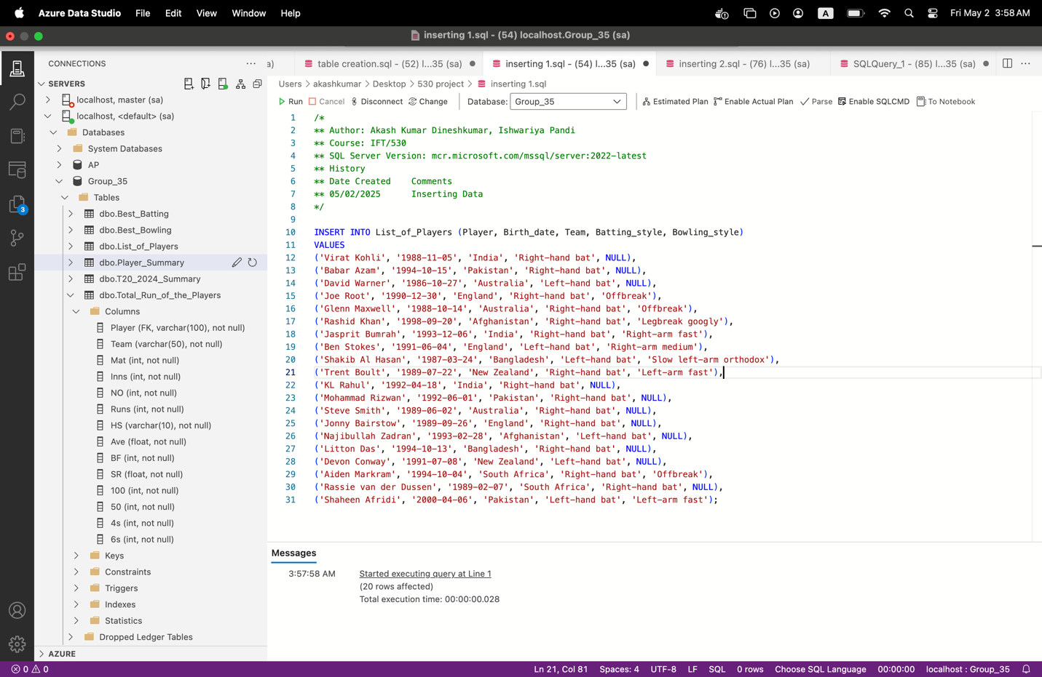

**Total_Run_of_the_Players**

INSERT INTO Total_Run_of_the_Players

(Player, Team, Mat, Inns, NO, Runs, HS, Ave, BF, SR, [100], [50], [4s], [6s])

VALUES

('Virat Kohli', 'India', 8, 8, 2, 320, '82*', 53.3, 236, 135.5, 0, 3, 32, 5),

('Babar Azam', 'Pakistan', 8, 8, 2, 305, '74', 50.8, 231, 132.1, 0, 4, 29, 6),

('David Warner', 'Australia', 8, 8, 1, 289, '85', 48.1, 223, 129.6, 1, 2, 28, 7),

('Joe Root', 'England', 7, 7, 1, 245, '68', 40.8, 206, 118.7, 0, 3, 21, 3),

('Glenn Maxwell', 'Australia', 8, 8, 0, 310, '101', 38.7, 217, 142.5, 1, 1, 35, 10),

('Rashid Khan', 'Afghanistan', 7, 5, 2, 97, '36', 16.2, 88, 110.2, 0, 0, 8, 4),

('Jasprit Bumrah', 'India', 7, 4, 1, 36, '18', 12.0, 40, 91.2, 0, 0, 2, 1),

('Ben Stokes', 'England', 7, 6, 2, 195, '56', 32.5, 161, 121.3, 0, 2, 19, 5),

('Shakib Al Hasan', 'Bangladesh', 7, 7, 1, 180, '61', 30.0, 156, 115.4, 0, 2, 16, 4),

('Trent Boult', 'New Zealand', 7, 2, 0, 22, '12', 7.3, 30, 75.0, 0, 0, 1, 0),

('KL Rahul', 'India', 6, 6, 1, 210, '71', 42.0, 180, 116.6, 0, 2, 25, 6),

('Mohammad Rizwan', 'Pakistan', 6, 6, 2, 180, '67', 45.0, 160, 112.5, 0, 2, 22, 3),

('Steve Smith', 'Australia', 6, 6, 1, 155, '58', 31.0, 140, 110.7, 0, 1, 20, 1),

('Jonny Bairstow', 'England', 6, 6, 0, 190, '75', 31.7, 165, 115.2, 0, 2, 24, 5),

('Najibullah Zadran', 'Afghanistan', 6, 6, 0, 125, '45', 20.8, 118, 106.0, 0, 0, 14, 2),

('Litton Das', 'Bangladesh', 6, 6, 0, 134, '49', 22.3, 125, 107.2, 0, 0, 15, 3),

('Devon Conway', 'New Zealand', 6, 6, 1, 172, '70', 34.4, 150, 114.6, 0, 2, 21, 4),

('Aiden Markram', 'South Africa', 6, 6, 1, 160, '59', 32.0, 140, 114.3, 0, 2, 20, 3),

('Rassie van der Dussen', 'South Africa', 6, 6, 0, 175, '66', 29.2, 158, 110.8, 0, 2, 19, 2),

('Shaheen Afridi', 'Pakistan', 6, 2, 0, 25, '13', 12.5, 28, 89.2, 0, 0, 2, 0);

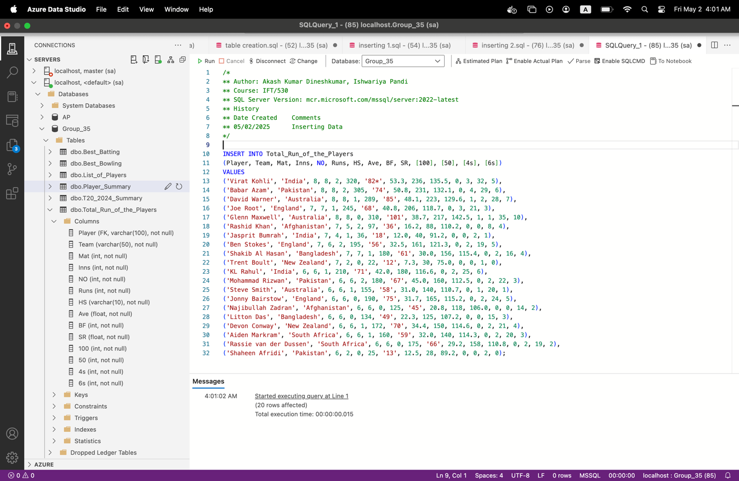

**Best_Bowling**

INSERT INTO Best_Bowling (Player, Team, Mat, Inns, Balls, Overs, Mdns, Runs, Wkts, BBI, Ave, Econ, SR, "4", "5")

VALUES

('Virat Kohli', 'India', 10, 10, 600, 100, 0, 300, 5, '4/45', 60.00, 5.00, 30.0, 1, 0),

('Babar Azam', 'Pakistan', 12, 12, 720, 120, 0, 350, 8, '5/50', 43.75, 4.80, 28.0, 2, 0),

('David Warner', 'Australia', 15, 15, 900, 150, 0, 450, 12, '3/40', 37.50, 5.00, 25.0, 0, 0),

('Joe Root', 'England', 14, 14, 840, 140, 1, 400, 10, '4/60', 40.00, 4.75, 26.0, 1, 0),

('Glenn Maxwell', 'Australia', 8, 8, 480, 80, 0, 250, 6, '3/30', 41.67, 5.20, 27.5, 0, 0),

('Rashid Khan', 'Afghanistan', 12, 12, 720, 120, 0, 300, 14, '5/40', 21.43, 4.00, 25.0, 2, 1),

('Jasprit Bumrah', 'India', 10, 10, 600, 100, 0, 280, 9, '4/35', 31.11, 4.50, 27.0, 1, 0),

('Ben Stokes', 'England', 11, 11, 660, 110, 0, 320, 7, '3/50', 45.71, 4.80, 28.0, 1, 0),

('Shakib Al Hasan', 'Bangladesh', 13, 13, 780, 130, 0, 360, 9, '4/55', 40.00, 4.60, 30.0, 1, 0),

('Trent Boult', 'New Zealand', 14, 14, 840, 140, 0, 380, 11, '5/45', 34.55, 4.50, 26.0, 2, 0),

('KL Rahul', 'India', 9, 9, 540, 90, 0, 250, 5, '3/40', 50.00, 4.60, 30.0, 1, 0),

('Mohammad Rizwan', 'Pakistan', 7, 7, 420, 70, 0, 180, 3, '2/30', 60.00, 4.50, 28.0, 0, 0),

('Steve Smith', 'Australia', 10, 10, 600, 100, 0, 300, 4, '3/45', 75.00, 5.00, 35.0, 1, 0),

('Jonny Bairstow', 'England', 11, 11, 660, 110, 0, 320, 8, '4/50', 40.00, 4.90, 30.0, 1, 0),

('Najibullah Zadran', 'Afghanistan', 6, 6, 360, 60, 0, 180, 2, '2/25', 90.00, 5.00, 32.0, 0, 0),

('Litton Das', 'Bangladesh', 8, 8, 480, 80, 0, 220, 4, '3/40', 55.00, 4.75, 30.0, 1, 0),

('Devon Conway', 'New Zealand', 13, 13, 780, 130, 0, 380, 9, '4/60', 42.22, 4.80, 30.0, 1, 0),

('Aiden Markram', 'South Africa', 10, 10, 600, 100, 0, 270, 6, '3/40', 45.00, 4.50, 29.0, 1, 0),

('Rassie van der Dussen', 'South Africa', 12, 12, 720, 120, 0, 350, 8, '4/50', 43.75, 4.80, 28.0, 2, 0),

('Shaheen Afridi', 'Pakistan', 14, 14, 840, 140, 0, 400, 10, '5/45', 40.00, 4.75, 26.5, 2, 1);

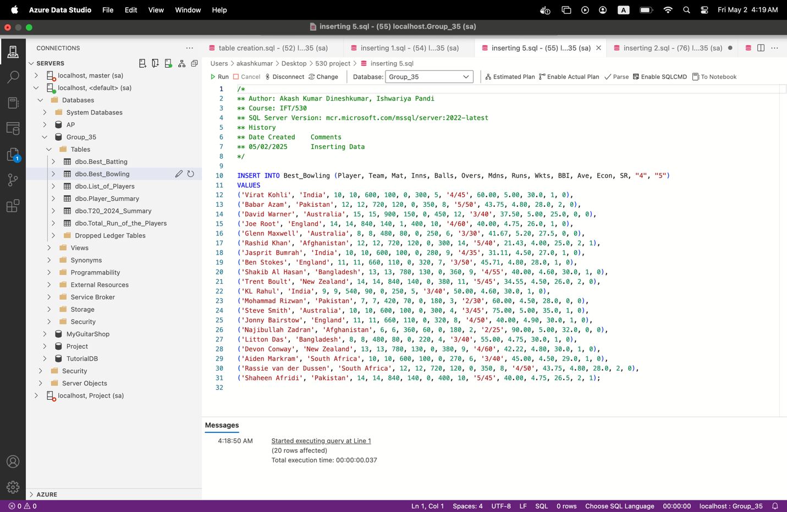

**Best_Batting**

INSERT INTO Best_Batting

(Player, Runs, Mins, Balls, [4s], [6s], SR, Team, Opposition, Ground, Match_Date)

VALUES

('Virat Kohli', '82', 80, 60, 8, 2, 136.7, 'India', 'Pakistan', 'Eden Gardens', '2024-06-01'),

('Babar Azam', '74', 78, 55, 7, 1, 134.5, 'Pakistan', 'India', 'Eden Gardens', '2024-06-03'),

('David Warner', '85', 90, 61, 9, 3, 139.3, 'Australia', 'England', 'MCG', '2024-06-02'),

('Joe Root', '68', 75, 58, 5, 2, 117.2, 'England', 'Australia', 'MCG', '2024-06-07'),

('Glenn Maxwell', '101', 85, 67, 10, 4, 150.7, 'Australia', 'Bangladesh', 'Gabba', '2024-06-06'),

('Rashid Khan', '36', 35, 30, 4, 2, 120.0, 'Afghanistan', 'Bangladesh', 'Sher-e-Bangla', '2024-06-08'),

('Jasprit Bumrah', '18', 20, 15, 2, 1, 120.0, 'India', 'New Zealand', 'Wankhede', '2024-06-04'),

('Ben Stokes', '56', 65, 42, 5, 2, 133.3, 'England', 'Pakistan', 'Oval', '2024-06-05'),

('Shakib Al Hasan', '61', 72, 49, 5, 2, 124.5, 'Bangladesh', 'India', 'Hyderabad', '2024-06-11'),

('Trent Boult', '12', 15, 10, 1, 0, 120.0, 'New Zealand', 'Bangladesh', 'Hamilton', '2024-06-20'),

('KL Rahul', '71', 85, 50, 7, 2, 142.0, 'India', 'Afghanistan', 'Ahmedabad', '2024-06-18'),

('Mohammad Rizwan', '67', 78, 48, 6, 1, 139.6, 'Pakistan', 'England', 'Oval', '2024-06-13'),

('Steve Smith', '58', 68, 43, 5, 1, 134.8, 'Australia', 'Afghanistan', 'SCG', '2024-06-10'),

('Jonny Bairstow', '75', 88, 55, 6, 3, 136.3, 'England', 'Afghanistan', 'Lords', '2024-06-12'),

('Litton Das', '49', 65, 38, 5, 2, 128.9, 'Bangladesh', 'Afghanistan', 'Sher-e-Bangla', '2024-06-23'),

('Najibullah Zadran', '45', 55, 35, 4, 1, 128.6, 'Afghanistan', 'Pakistan', 'Karachi', '2024-06-16'),

('Devon Conway', '70', 84, 52, 6, 2, 134.6, 'New Zealand', 'Bangladesh', 'Hamilton', '2024-06-22'),

('Aiden Markram', '59', 70, 45, 5, 2, 131.1, 'South Africa', 'Australia', 'Adelaide', '2024-06-15'),

('Rassie van der Dussen', '66', 80, 50, 6, 2, 132.0, 'South Africa', 'India', 'Wankhede', '2024-06-14'),

('Shaheen Afridi', '13', 15, 10, 1, 0, 130.0, 'Pakistan', 'Afghanistan', 'Karachi', '2024-06-17');

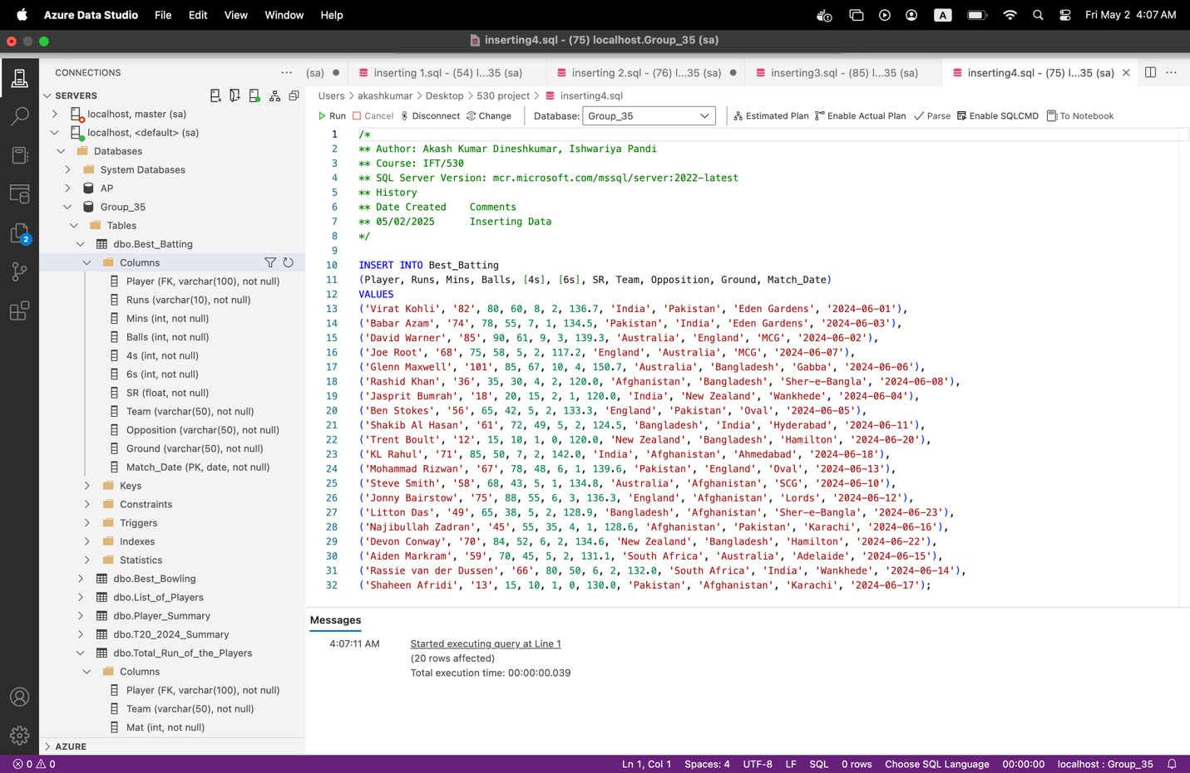

**Player_Summary**

INSERT INTO Player_Summary (Player, Team, Batting_style, Bowling_style, Runs, Batting_Avg, Batting_SR, Wickets, Bowling_Avg, Economy, Bowling_SR)

VALUES

('Virat Kohli', 'India', 'Right-hand bat', NULL, '320', '53.3', '135.5', NULL, NULL, NULL, NULL),

('Babar Azam', 'Pakistan', 'Right-hand bat', NULL, '305', '50.8', '132.1', NULL, NULL, NULL, NULL),

('David Warner', 'Australia', 'Left-hand bat', NULL, '289', '48.1', '129.6', NULL, NULL, NULL, NULL),

('Joe Root', 'England', 'Right-hand bat', 'Offbreak', '245', '40.8', '118.7', '4', '21.5', '6.0', '22.0'),

('Glenn Maxwell', 'Australia', 'Right-hand bat', 'Offbreak', '310', '38.7', '142.5', '5', '19.8', '6.3', '18.4'),

('Rashid Khan', 'Afghanistan', 'Right-hand bat', 'Legbreak googly', '97', '16.2', '110.2', '12', '14.5', '5.2', '16.5'),

('Jasprit Bumrah', 'India', 'Right-hand bat', 'Right-arm fast', '36', '12.0', '91.2', '14', '15.2', '5.8', '14.1'),

('Ben Stokes', 'England', 'Left-hand bat', 'Right-arm medium', '195', '32.5', '121.3', '7', '24.5', '6.8', '22.0'),

('Shakib Al Hasan', 'Bangladesh', 'Left-hand bat', 'Slow left-arm orthodox', '180', '30.0', '115.4', '10', '18.0', '5.5', '20.0'),

('Trent Boult', 'New Zealand', 'Right-hand bat', 'Left-arm fast', '22', '7.3', '75.0', '13', '13.8', '5.4', '13.0');

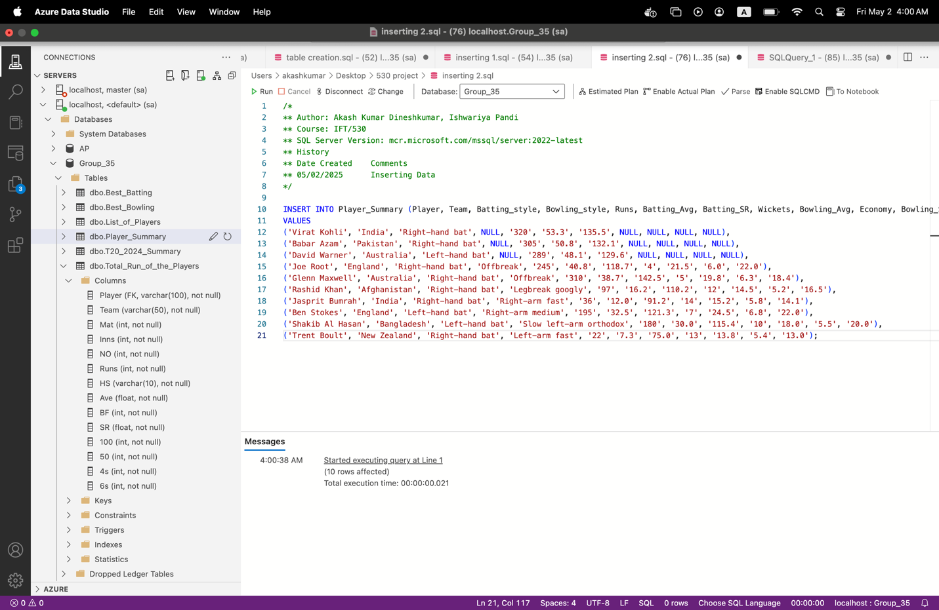

**Populating Tables:**

SELECT TOP 20 * FROM T20_2024_Summary;

SELECT TOP 20 * FROM Total_Run_of_the_Players;

SELECT TOP 20 * FROM Best_Bowling;

SELECT TOP 20 * FROM Best_Batting;

/* Dimensional Tables */

SELECT TOP 10 * FROM List_of_Players;

SELECT TOP 10 * FROM Player_Summary;

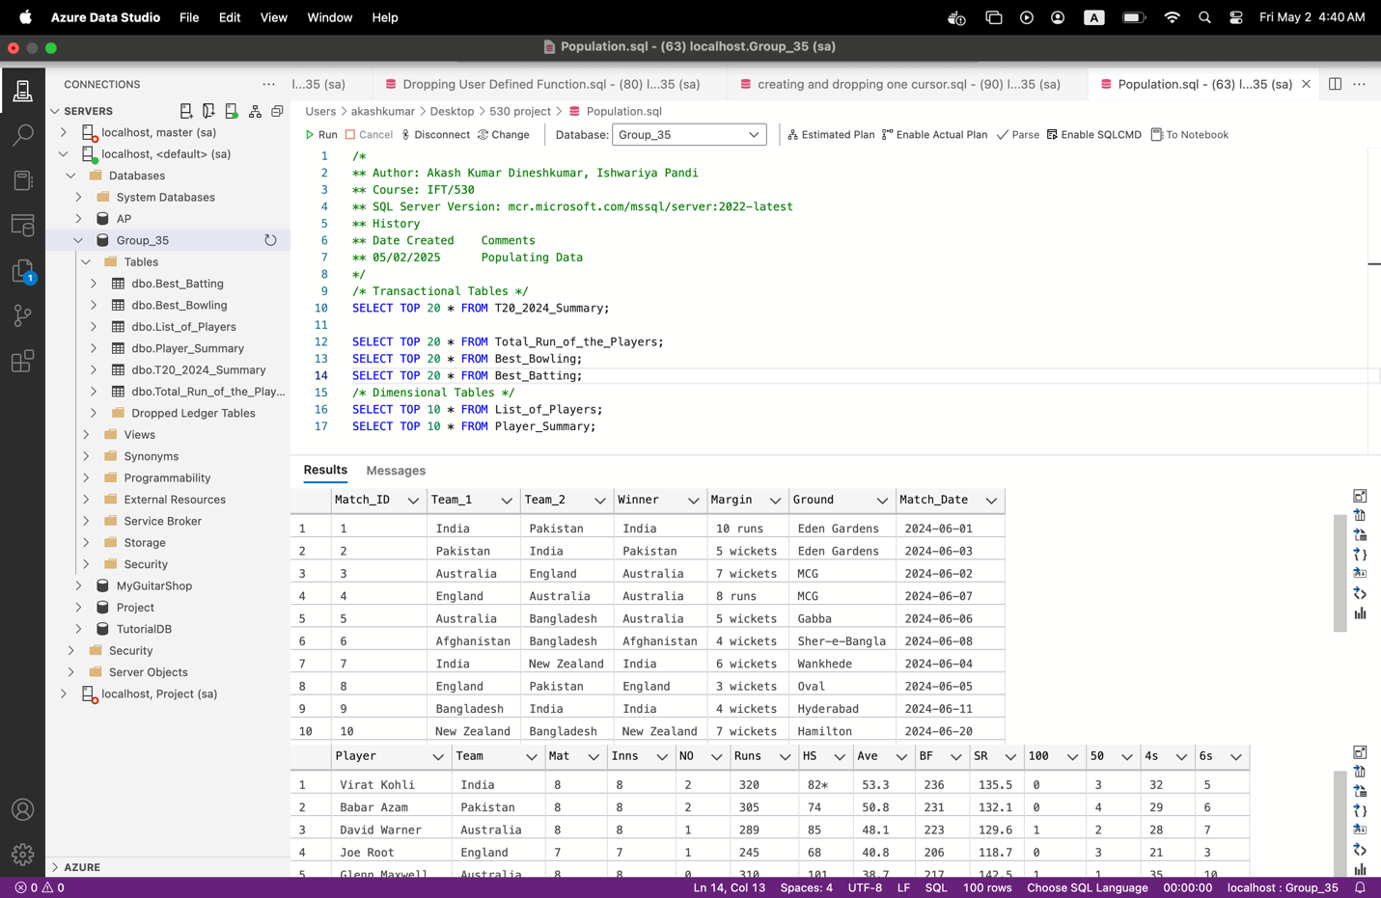

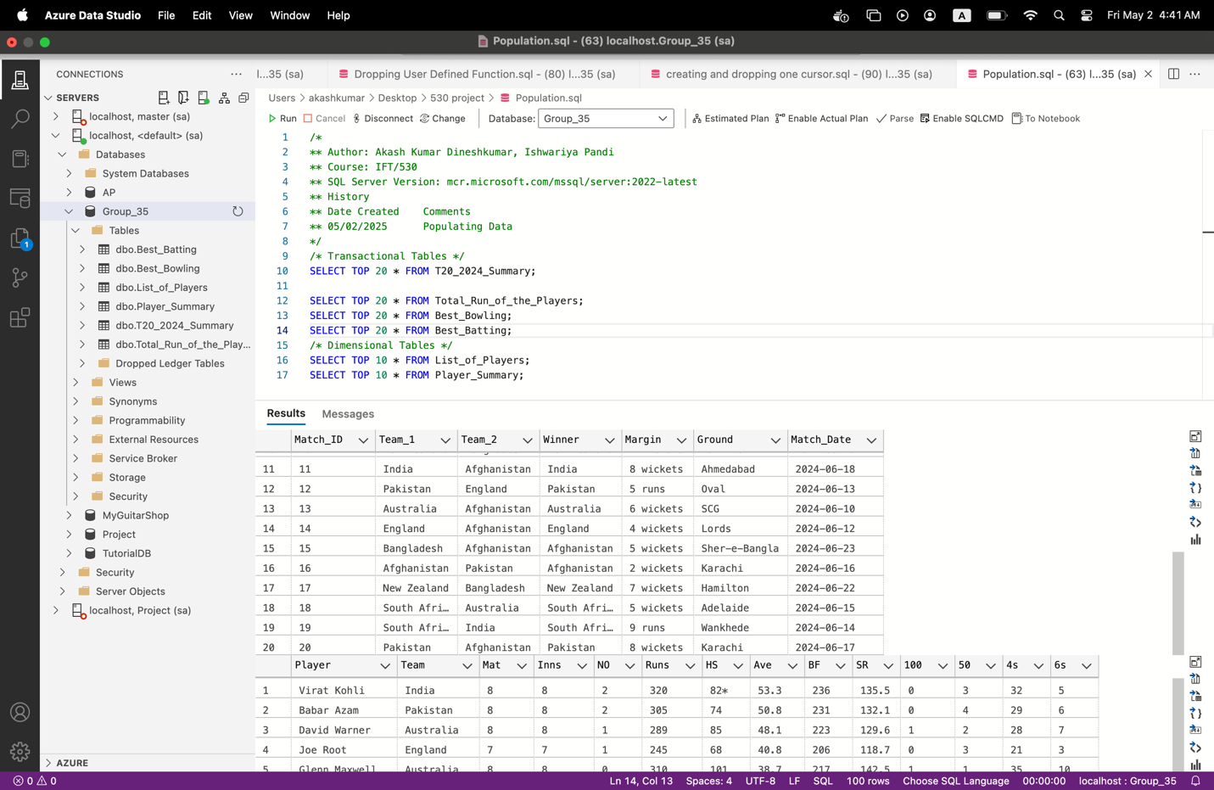

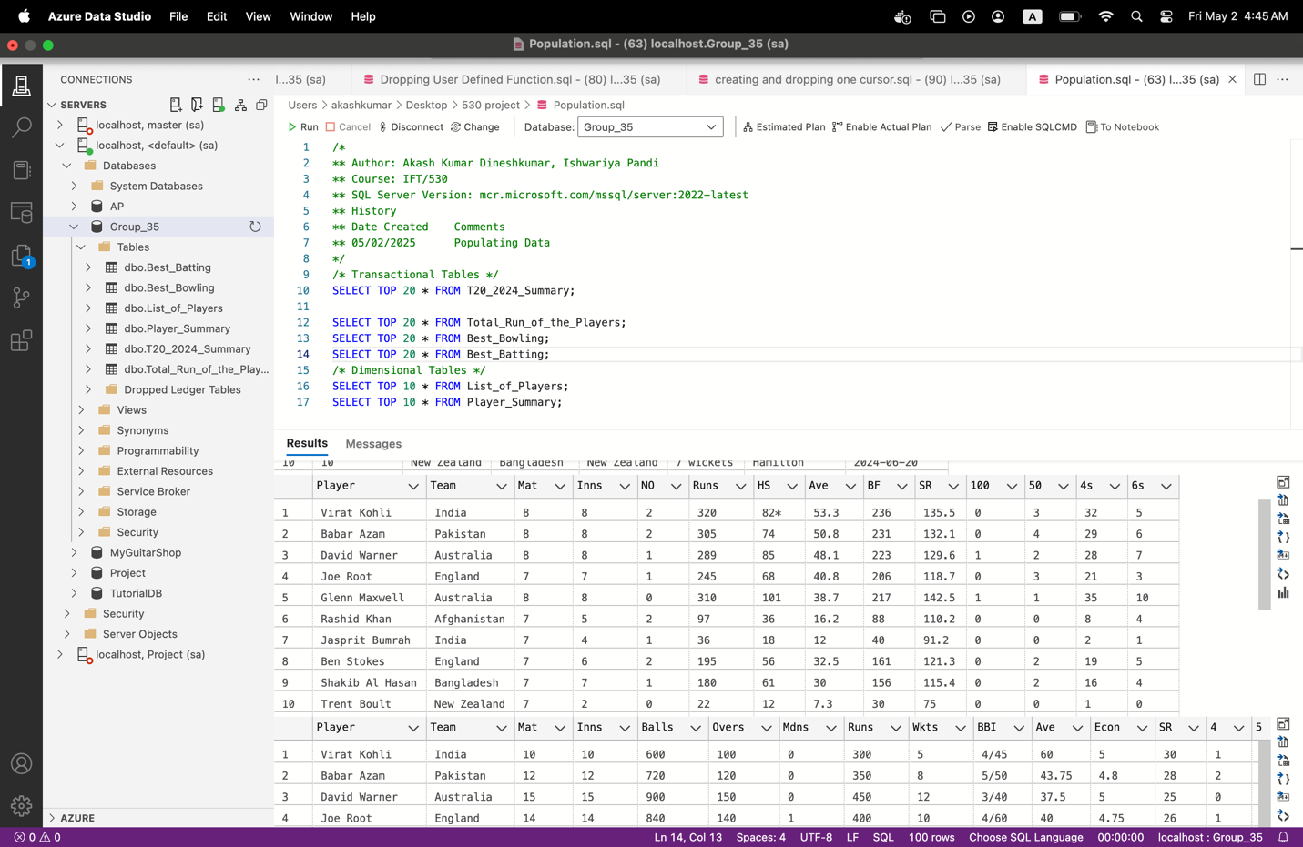

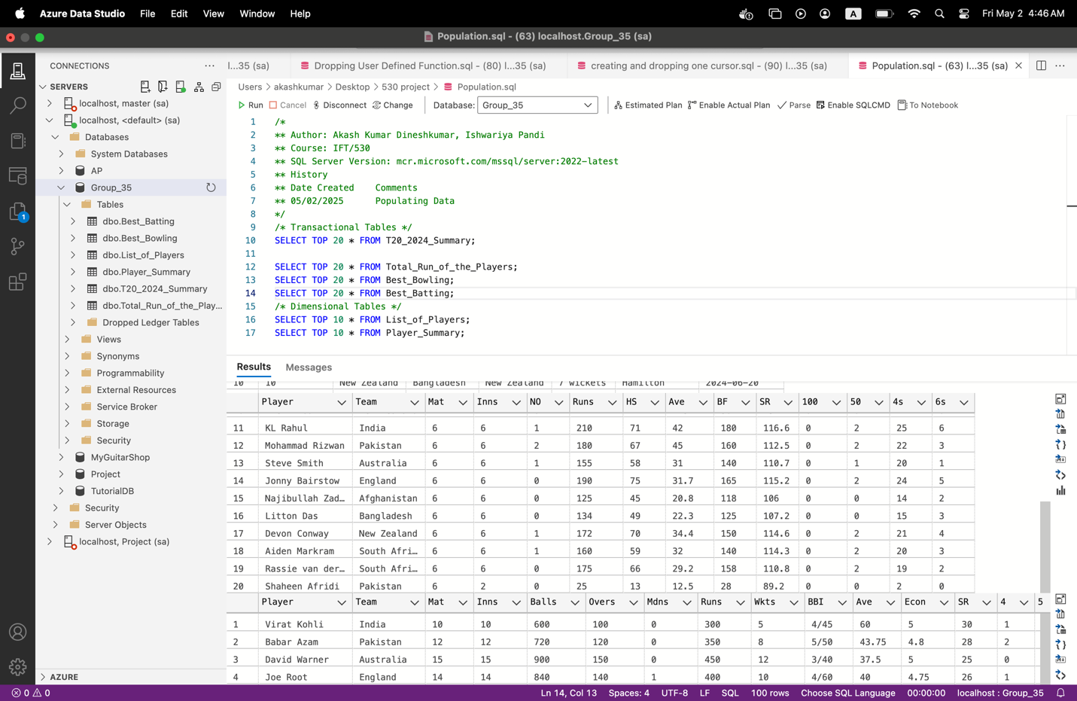

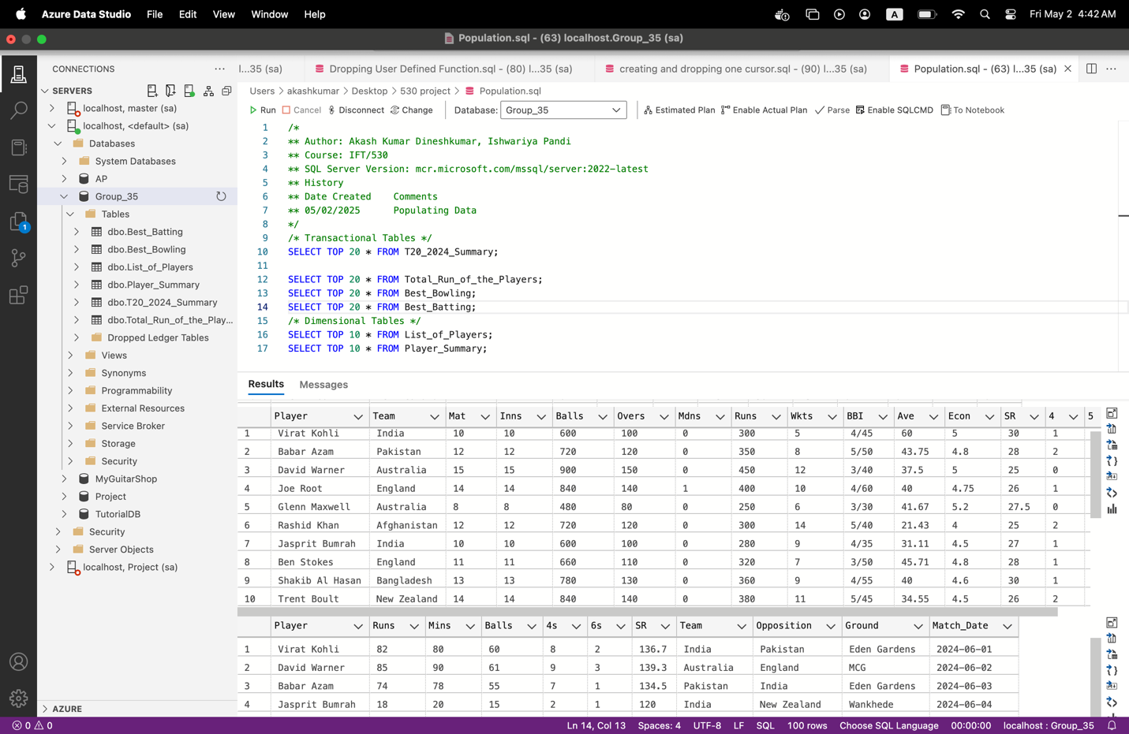

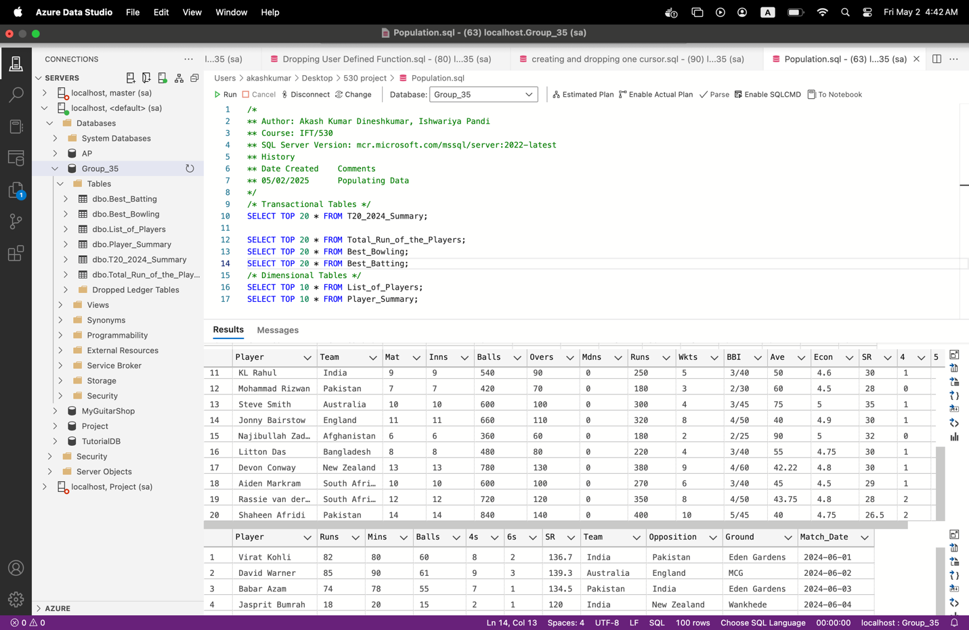

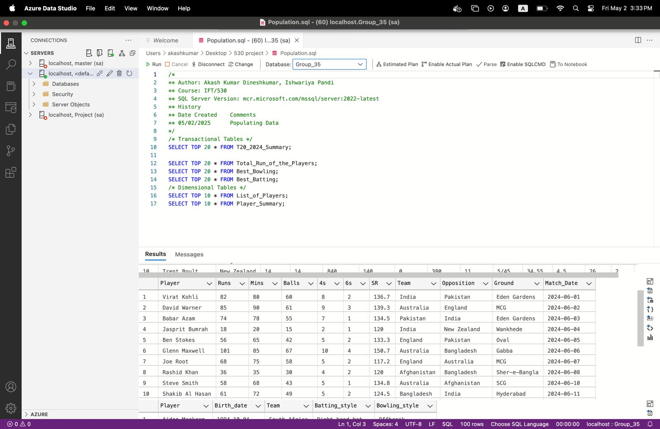

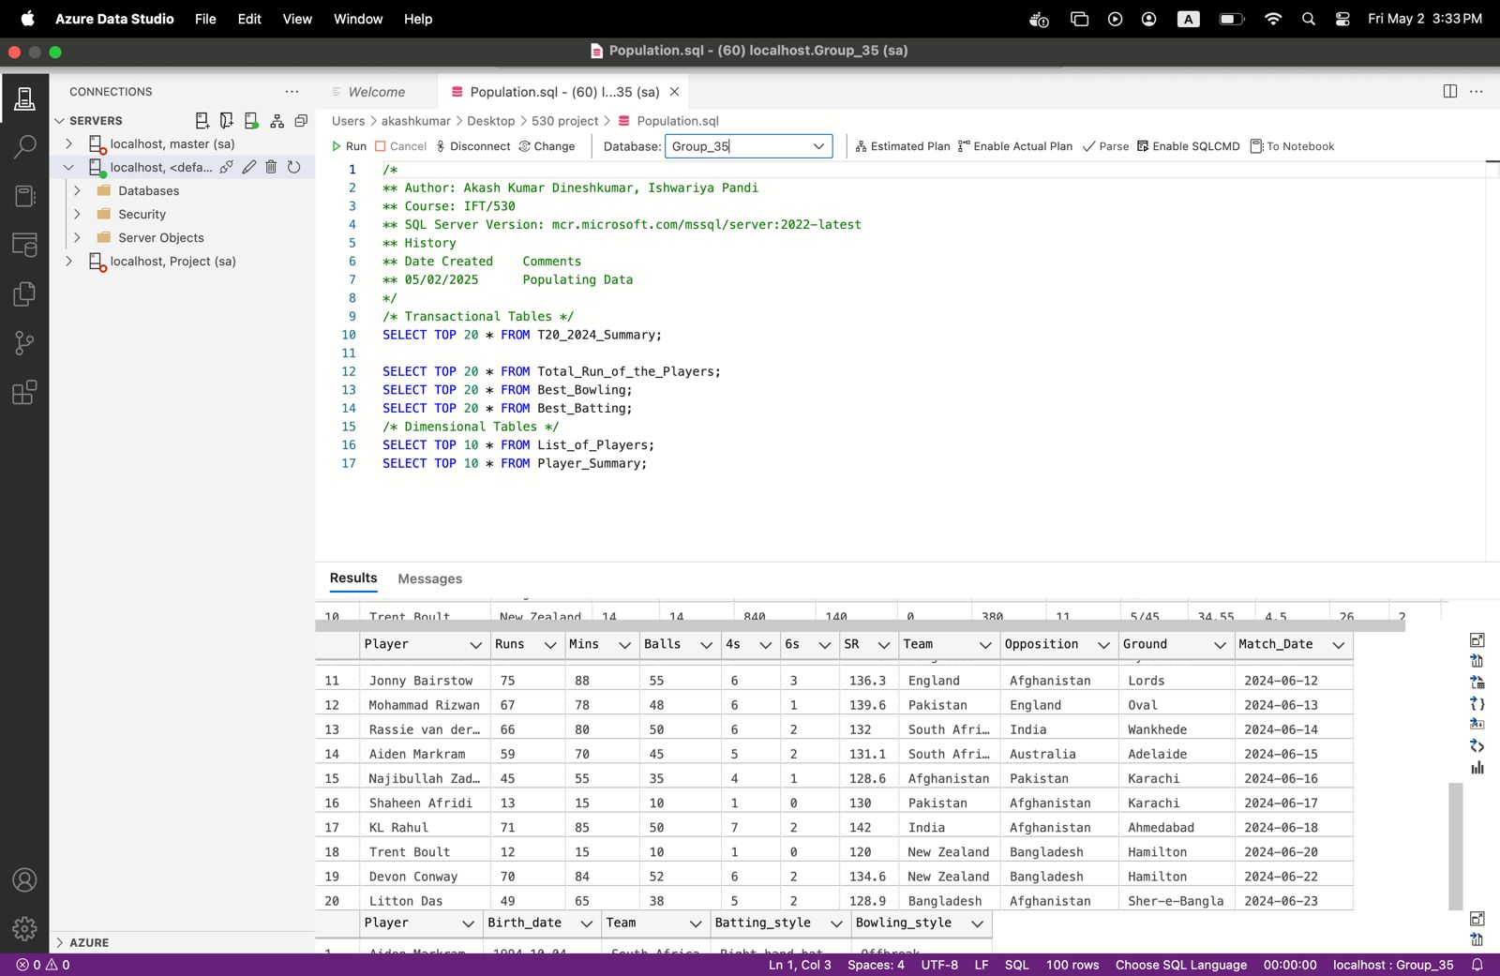

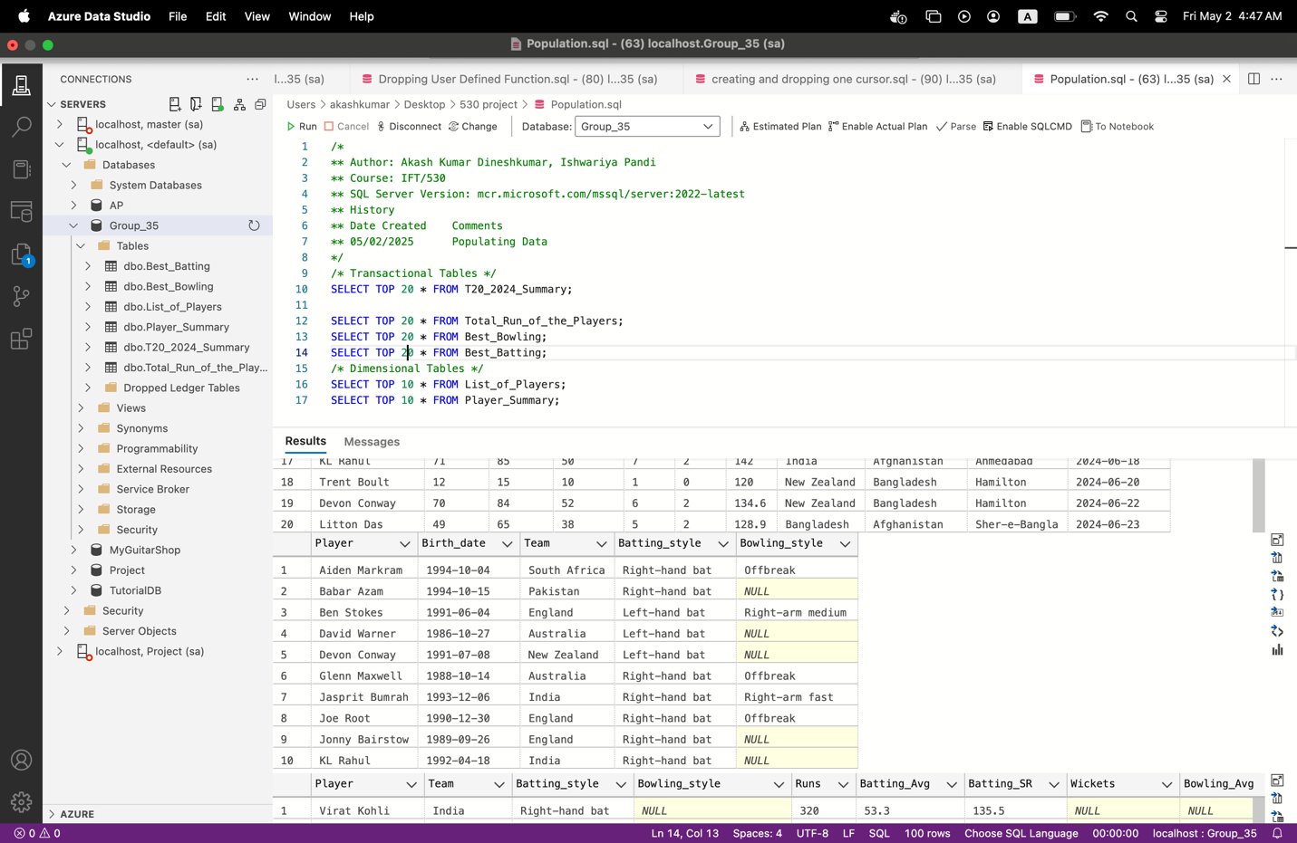

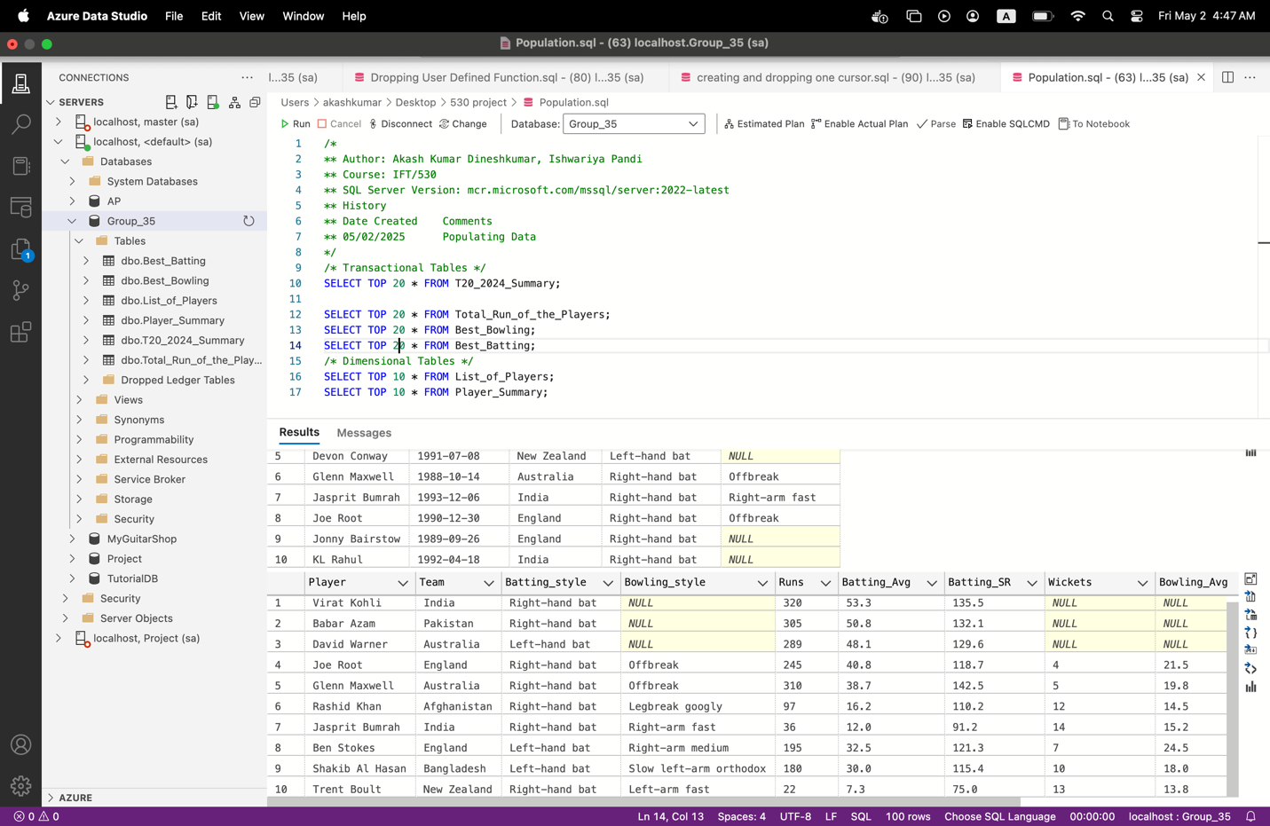

**Creating 3 queries:**

### **Query 1: View: Top Batsmen by Average**

**Purpose**: To help analysts and fans identify the top-performing batsmen with a batting average greater than 40.

CREATE VIEW Top_Batsmen_View AS

SELECT

ps.Player,

ps.Team,

ps.Runs,

ps.Batting_Avg,

lp.Batting_style

FROM

Player_Summary ps

JOIN

List_of_Players lp ON ps.Player = lp.Player

WHERE

CAST(ps.Batting_Avg AS FLOAT) > 40.0;

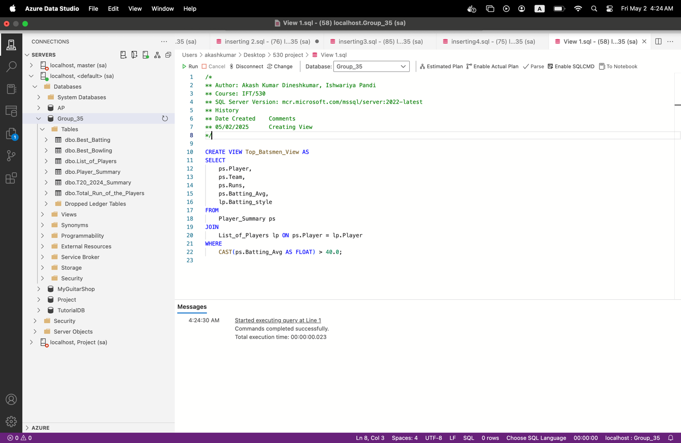

**Why it's useful**-  
The Top_Batsmen_View is a SQL view that highlights high-performing batsmen by joining the Player_Summary and List_of_Players tables. It filters players with a batting average above 40 using a WHERE clause and selects their name, team, total runs, average, and batting style. This view enables users to easily identify consistently successful batsmen. It’s especially useful for selectors making team decisions, fantasy league players looking for top picks, and analysts preparing match insights. The inclusion of batting style adds context to the stats, offering a well-rounded view. Ultimately, it simplifies performance tracking and supports strategic planning.

### **Query 2: View: Best Bowling Performances by Indian Players**

### **Purpose**: To extract elite bowling performances specifically from Indian players.

CREATE VIEW Indian_Best_Bowling_View AS

SELECT

bb.Player,

bb.Team,

bb.Wkts,

bb.BBI,

bb.Econ,

lp.Bowling_style

FROM

Best_Bowling bb

JOIN

List_of_Players lp ON bb.Player = lp.Player

WHERE

bb.Team = 'India' AND bb.Wkts >= 3;

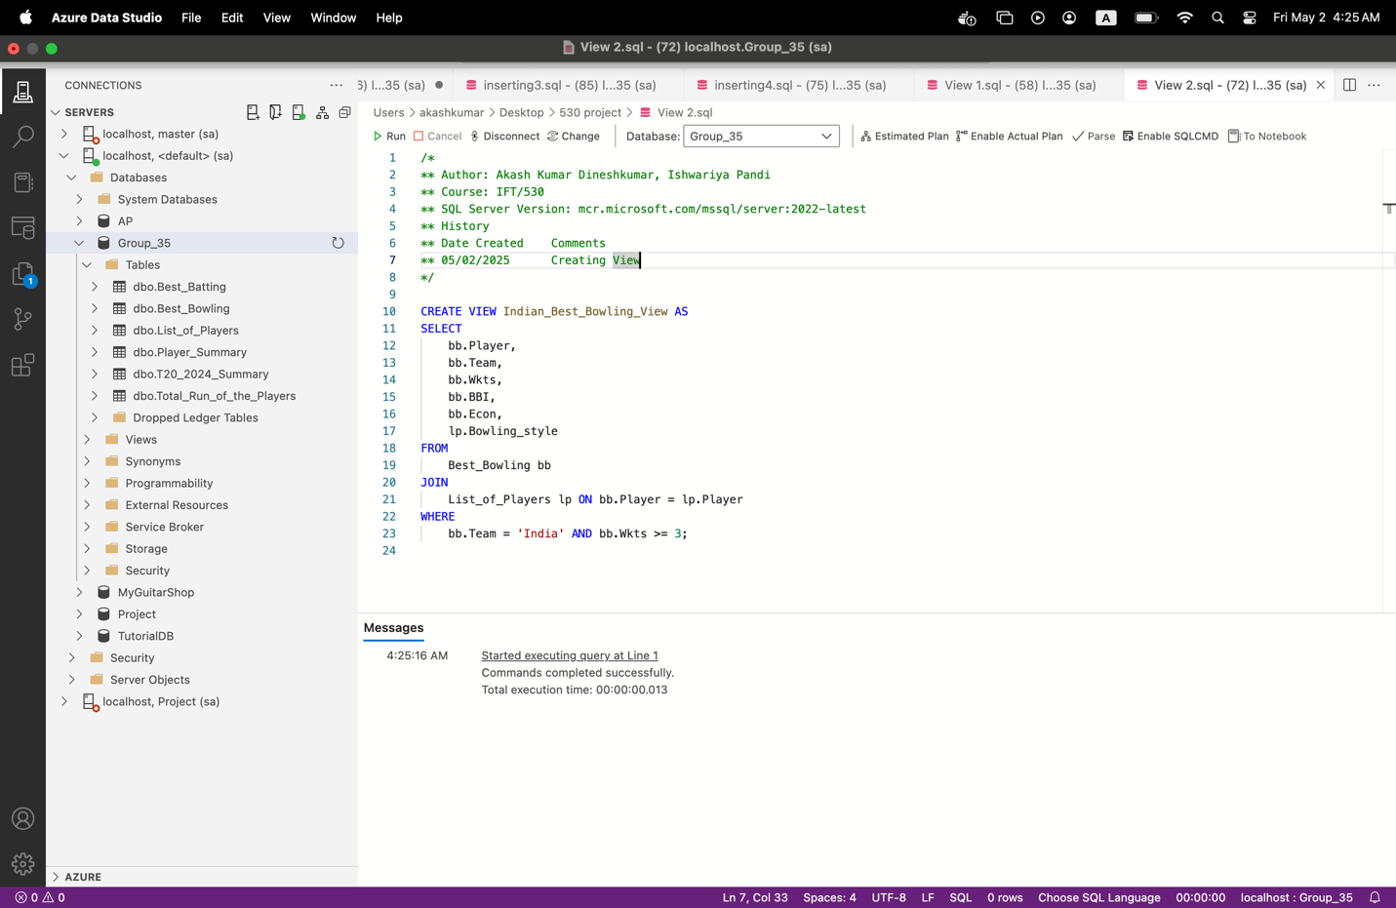

**Why it's useful**:

The Indian_Best_Bowling_View is a SQL view that highlights top bowling performances by Indian players. It joins the Best_Bowling and List_of_Players tables to include both performance data and bowling style. The view filters bowlers who have taken 3 or more wickets, ensuring only impactful performances are shown. Selected columns include player name, team, wickets taken, best bowling figures, economy rate, and style. This is useful for broadcasters creating highlights, selectors analyzing form, and fans exploring talent. It helps in quick identification of match-winning bowlers. Overall, the view supports performance tracking and cricket analytics specific to Indian bowlers.

### **Query 3: View: Match-Wise High Scoring Batsmen**

**Purpose**: To show players who scored 50 or more runs in matches played on or after June 10.

CREATE VIEW Match_High_Scorers_View AS

SELECT

bb.Player,

bb.Team,

bb.Runs,

bb.Opposition,

ts.Match_Date,

ts.Ground

FROM

Best_Batting bb

JOIN

T20_2024_Summary ts ON bb.Match_Date = ts.Match_Date

WHERE

CAST(bb.Runs AS INT) >= 50 AND ts.Match_Date >= '2024-06-04';

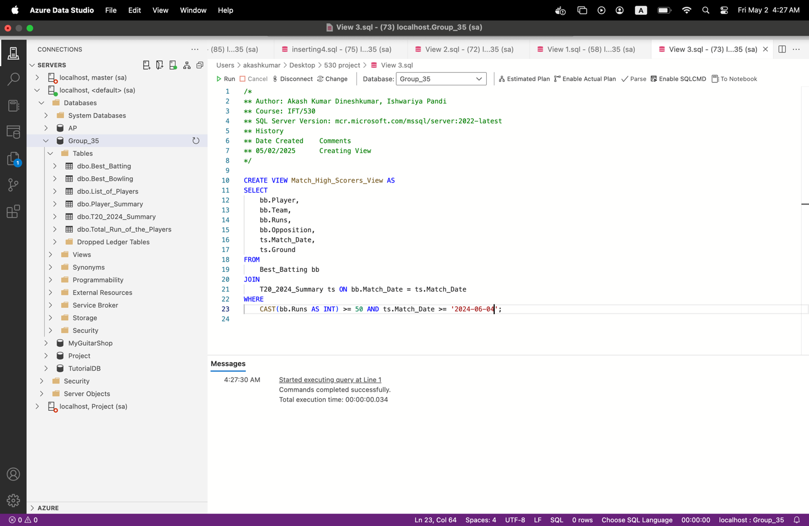

**Why it's useful**:

The Match_High_Scorers_View is a SQL view that displays players who scored 50 or more runs in matches played on or after June 10. It joins the Best_Batting and T20_2024_Summary tables to combine individual performance with match context. The view filters for impactful batting contributions in the later phase of the tournament. It includes player name, team, runs scored, opponent, match date, and ground. This helps identify key performers in critical matches. It’s especially useful for post-match analysis, media highlights, and fan engagement. Overall, the view supports trend tracking and storytelling during the tournament.

**“Create an audit table for one of the lookup tables and demonstrate data saved to that audit table when data in the original table is inserted, modified, or deleted. Include an additional column in the audit table that will have a date time field when the data was changed in the original table. Include the script to test all the operations”**

**Create the Audit Table**

CREATE TABLE List_of_Players_Audit (

Audit_ID INT IDENTITY(1,1) PRIMARY KEY,

Operation_Type VARCHAR(10),

Player VARCHAR(100),

Birth_date DATE,

Team VARCHAR(50),

Batting_style VARCHAR(50),

Bowling_style VARCHAR(50),

Changed_At DATETIME DEFAULT GETDATE()

);

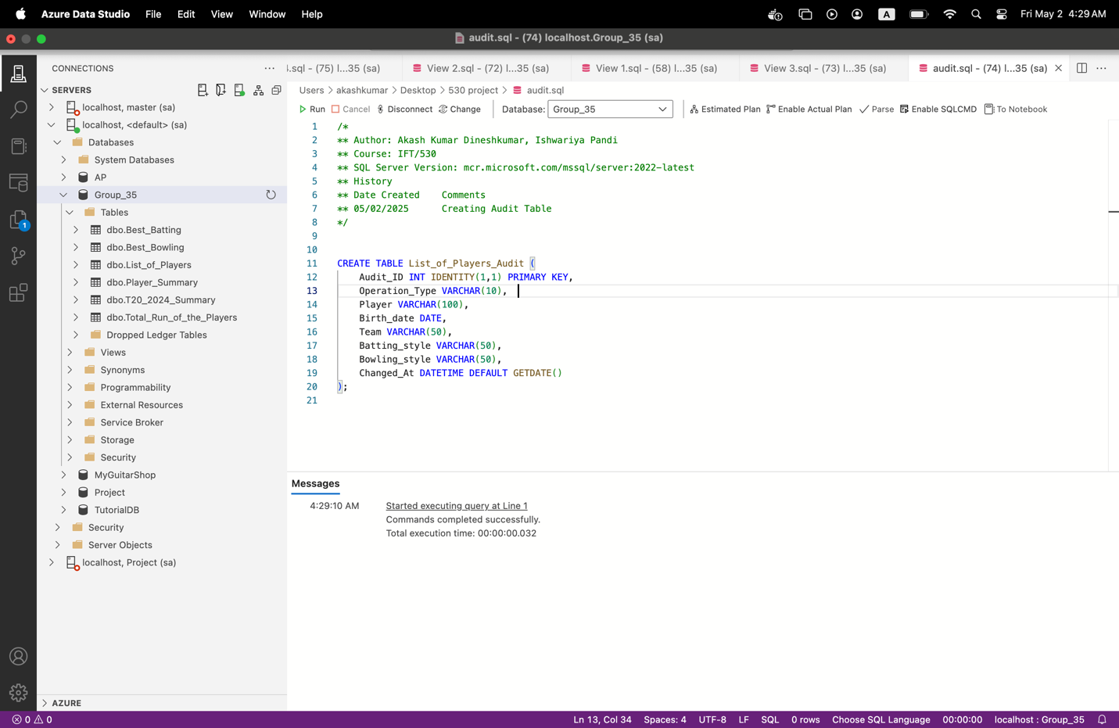

### **Create Triggers for Insert, Update, Delete**

#### **INSERT Trigger**

CREATE TRIGGER trg_List_of_Players_Insert

ON List_of_Players

AFTER INSERT

AS

BEGIN

INSERT INTO List_of_Players_Audit (Operation_Type, Player, Birth_date, Team, Batting_style, Bowling_style)

SELECT 'INSERT', Player, Birth_date, Team, Batting_style, Bowling_style

FROM inserted;

END;

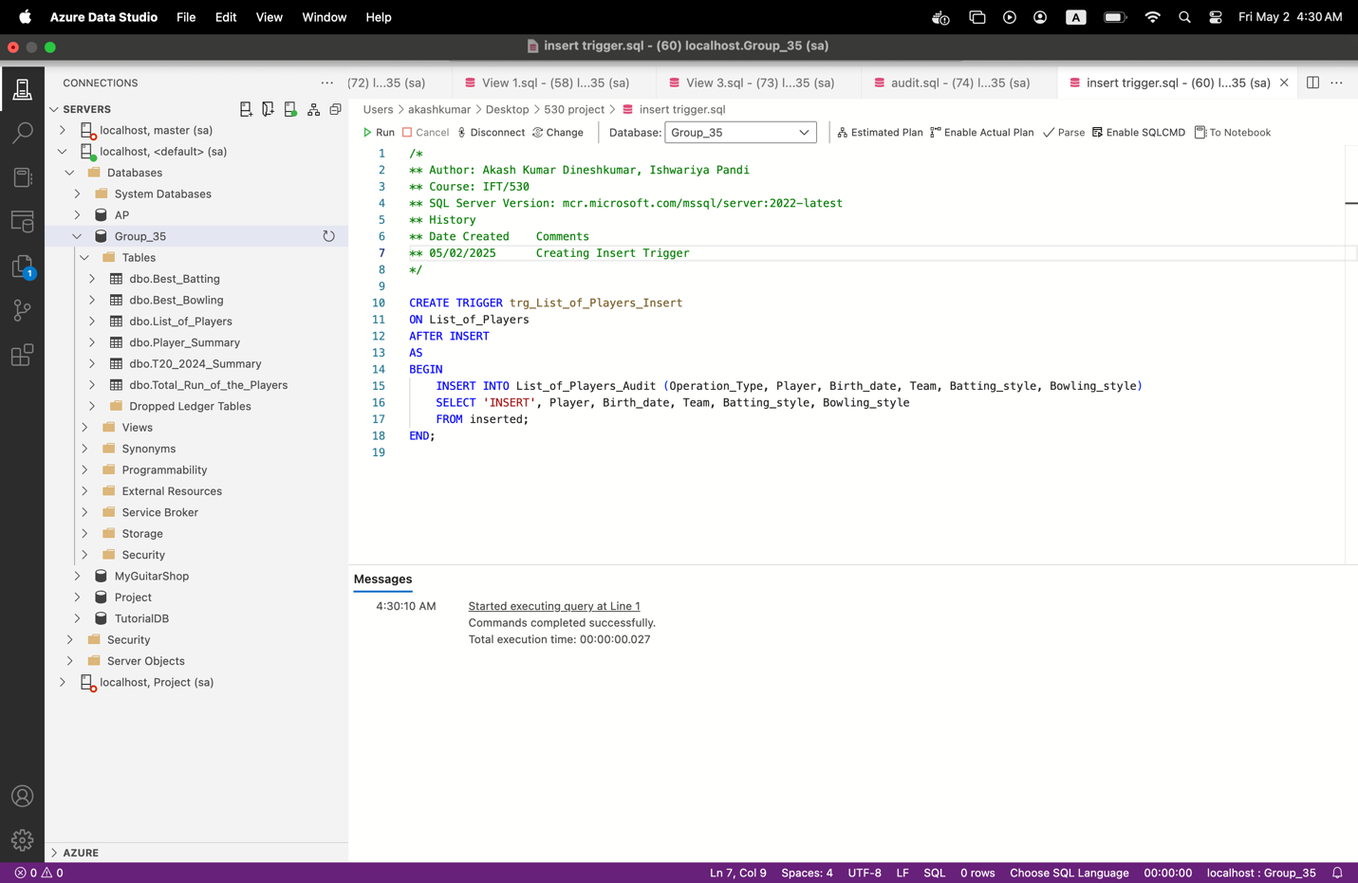

**UPDATE Trigger**

CREATE TRIGGER trg_List_of_Players_Update

ON List_of_Players

AFTER UPDATE

AS

BEGIN

INSERT INTO List_of_Players_Audit (Operation_Type, Player, Birth_date, Team, Batting_style, Bowling_style)

SELECT 'UPDATE', Player, Birth_date, Team, Batting_style, Bowling_style

FROM inserted;

END;

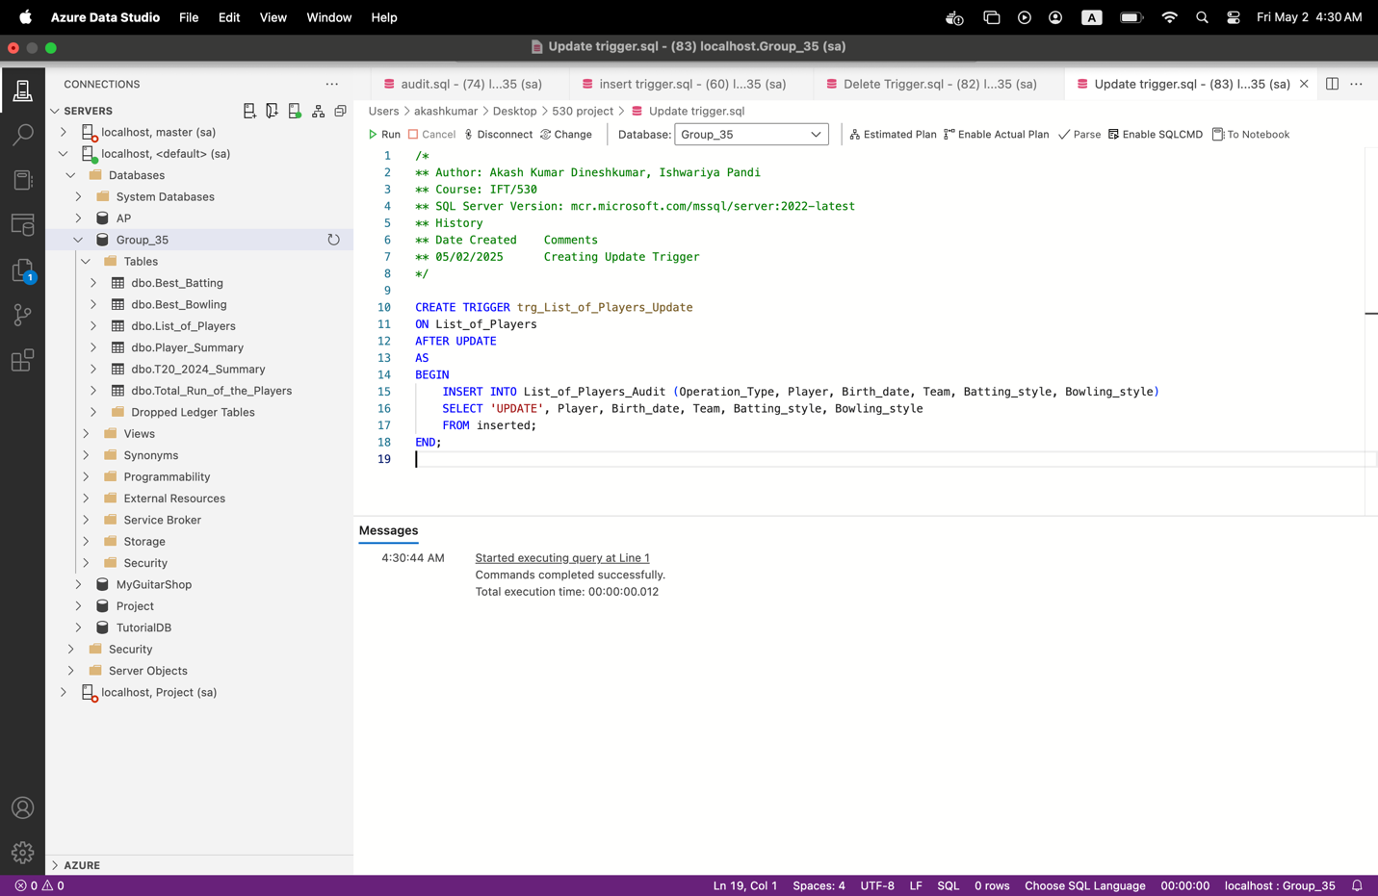

**DELETE Trigger**

CREATE TRIGGER trg_List_of_Players_Delete

ON List_of_Players

AFTER DELETE

AS

BEGIN

INSERT INTO List_of_Players_Audit (Operation_Type, Player, Birth_date, Team, Batting_style, Bowling_style)

SELECT 'DELETE', Player, Birth_date, Team, Batting_style, Bowling_style

FROM deleted;

END;

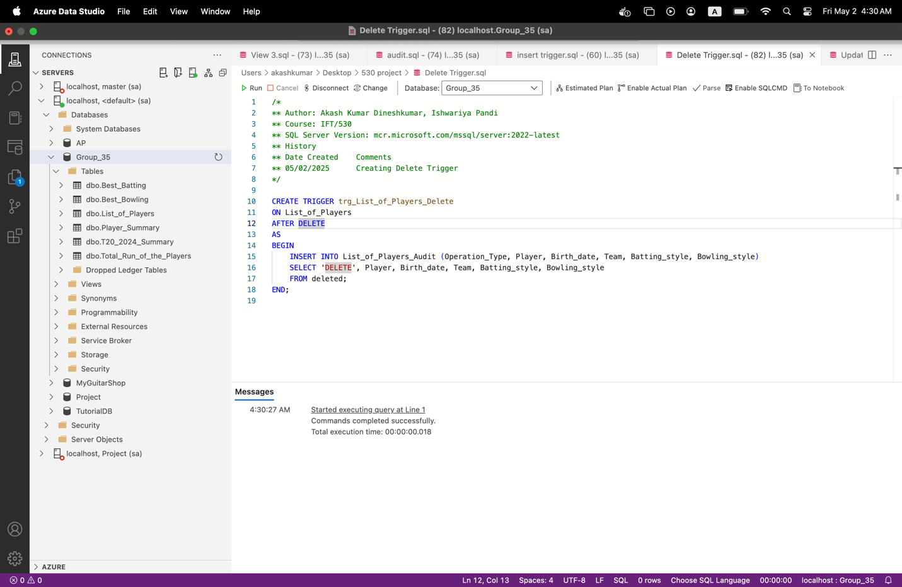

### **Testing the Triggers**

#### **Insert Test**

INSERT INTO List_of_Players (Player, Birth_date, Team, Batting_style, Bowling_style)

VALUES ('Suryakumar Yadav1', '1990-09-14', 'India', 'Right-hand bat', NULL);

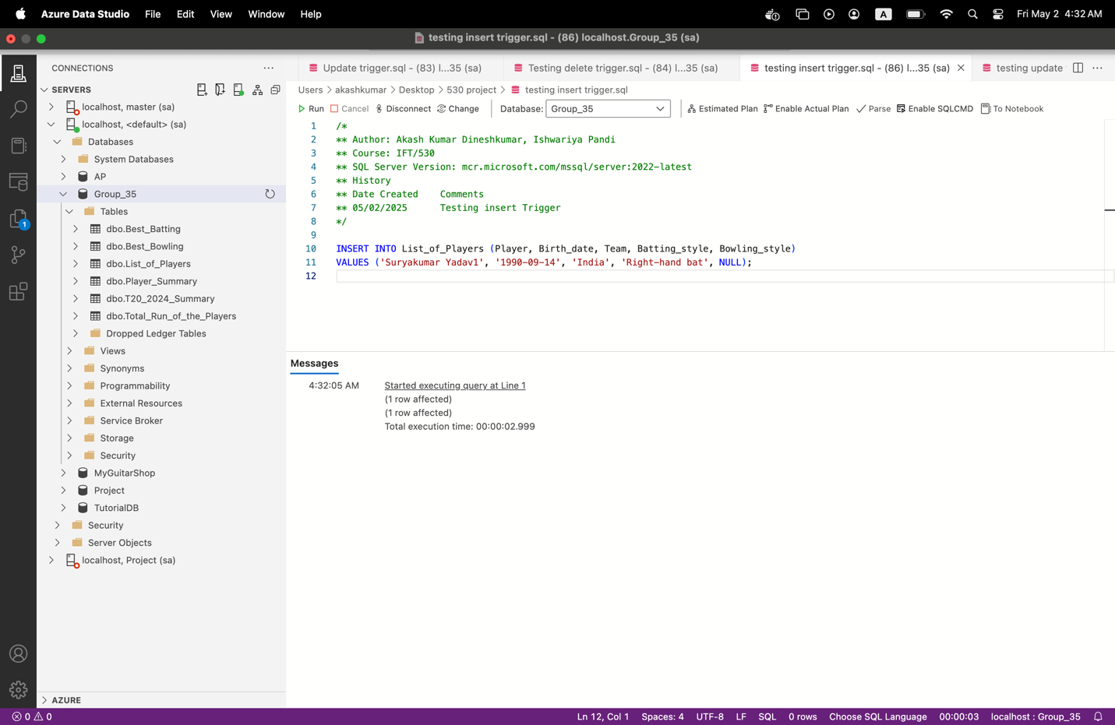

**Update Test**

UPDATE List_of_Players

SET Batting_style = 'Left-hand bat'

WHERE Player = 'Suryakumar Yadav1';

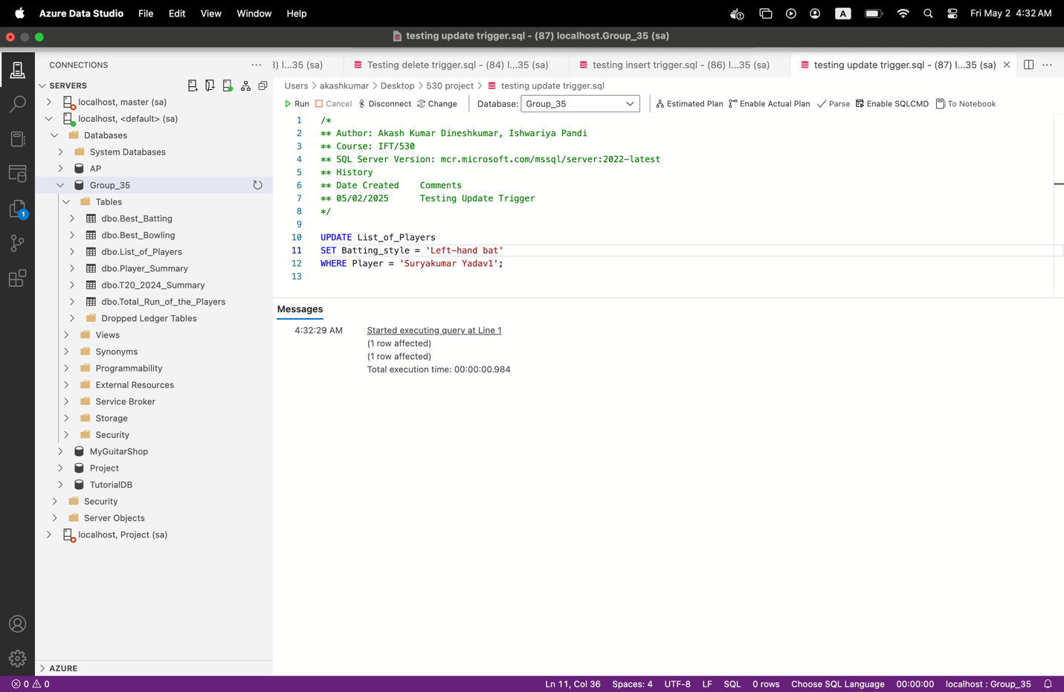

**Delete Test**

DELETE FROM List_of_Players

WHERE Player = 'Suryakumar Yadav1';

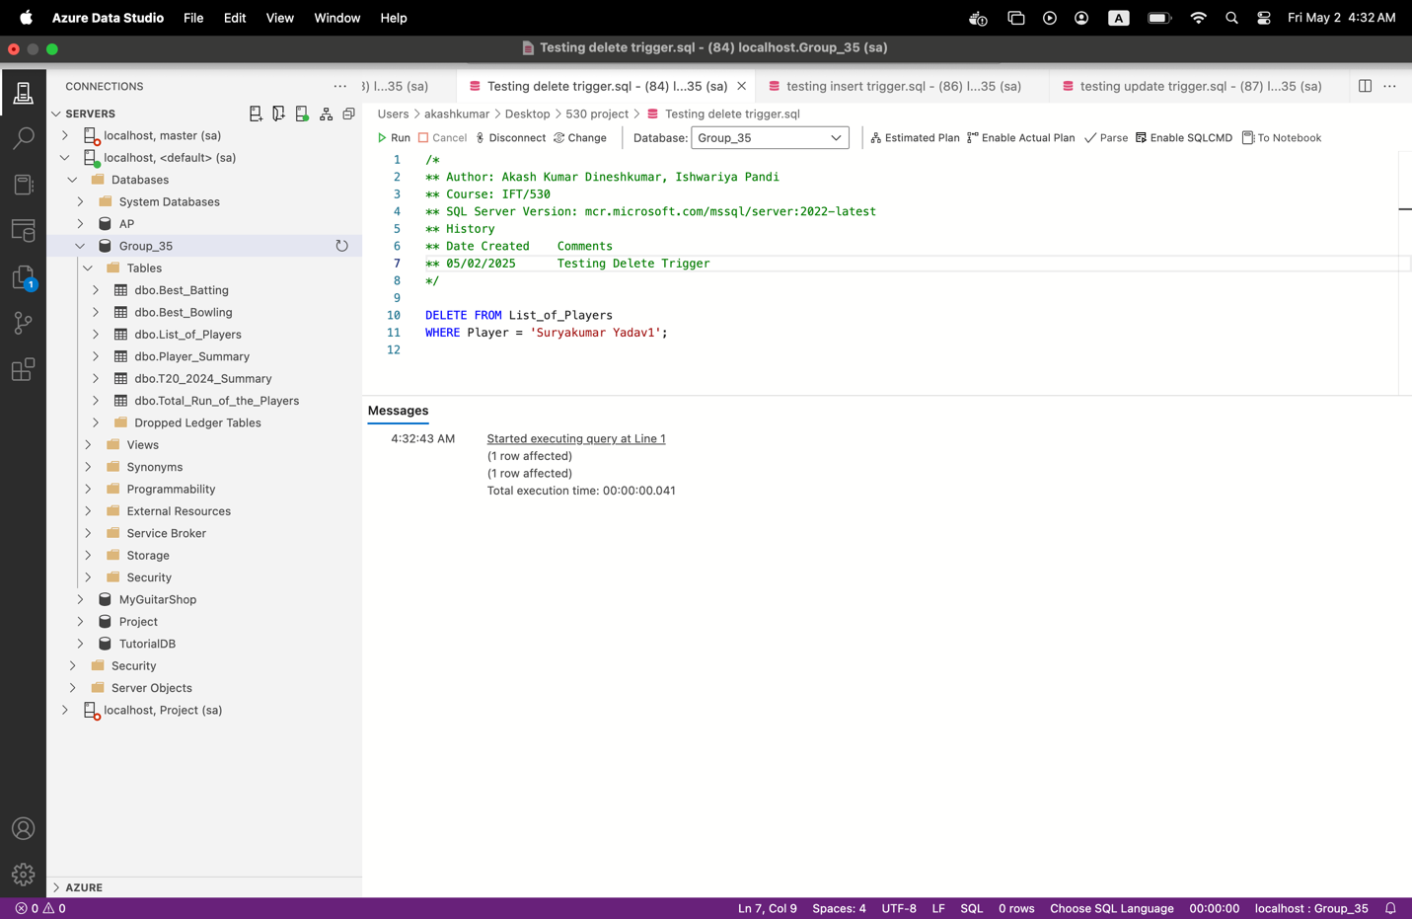

**View Audit Results**

SELECT * FROM List_of_Players_Audit;

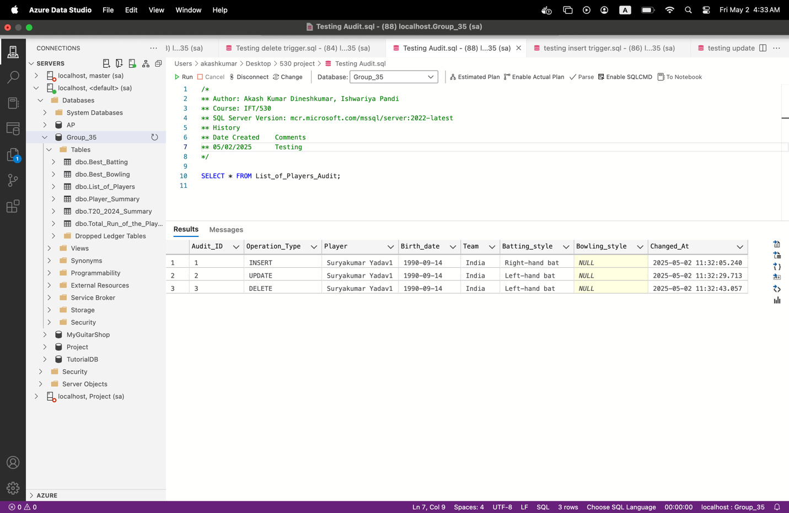

**Stored Procedure (SP):** **----- GetPlayerPerformance**

### **Purpose:** Retrieve **complete batting and bowling performance** of a player from Player_Summary table.

**Create Script**

CREATE PROCEDURE GetPlayerPerformance

@PlayerName VARCHAR(100)

AS

BEGIN

SELECT

Player,

Team,

Runs,

Batting_Avg,

Batting_SR,

Wickets,

Bowling_Avg,

Economy,

Bowling_SR

FROM

Player_Summary

WHERE

Player = @PlayerName;

END;

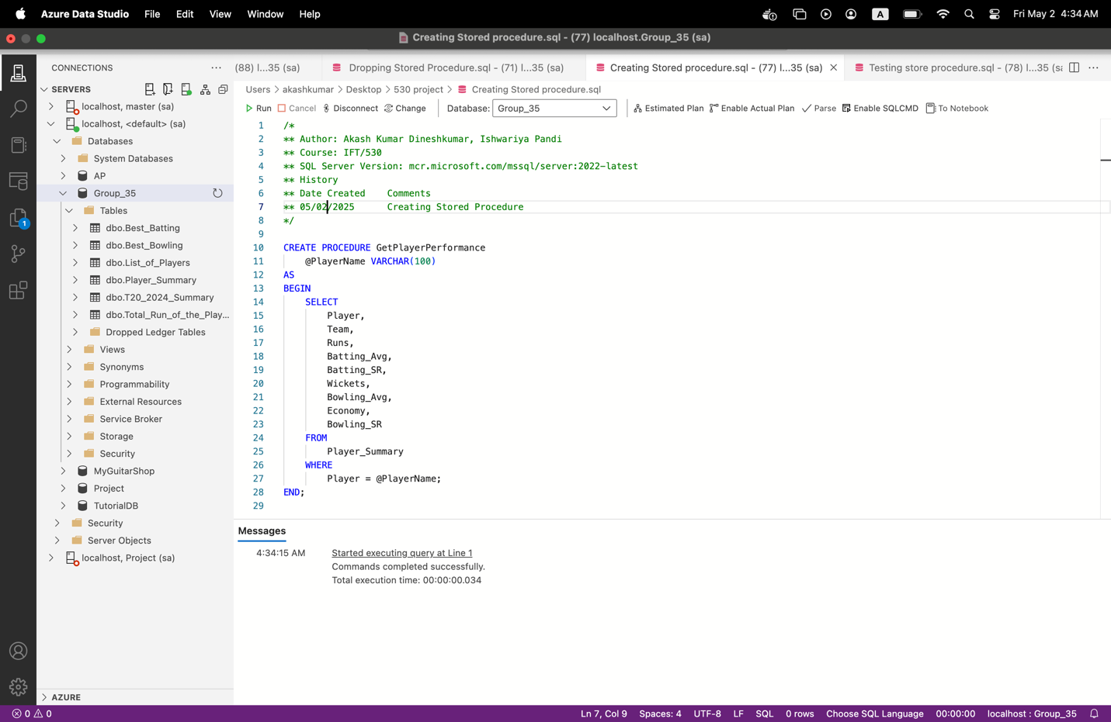

**Execution**

EXEC GetPlayerPerformance @PlayerName = 'Virat Kohli';

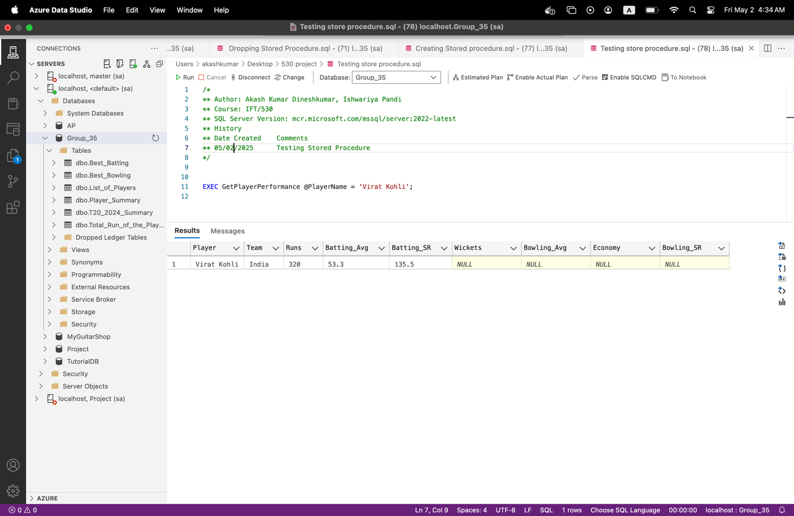

**Drop Script**

DROP PROCEDURE IF EXISTS GetPlayerPerformance;

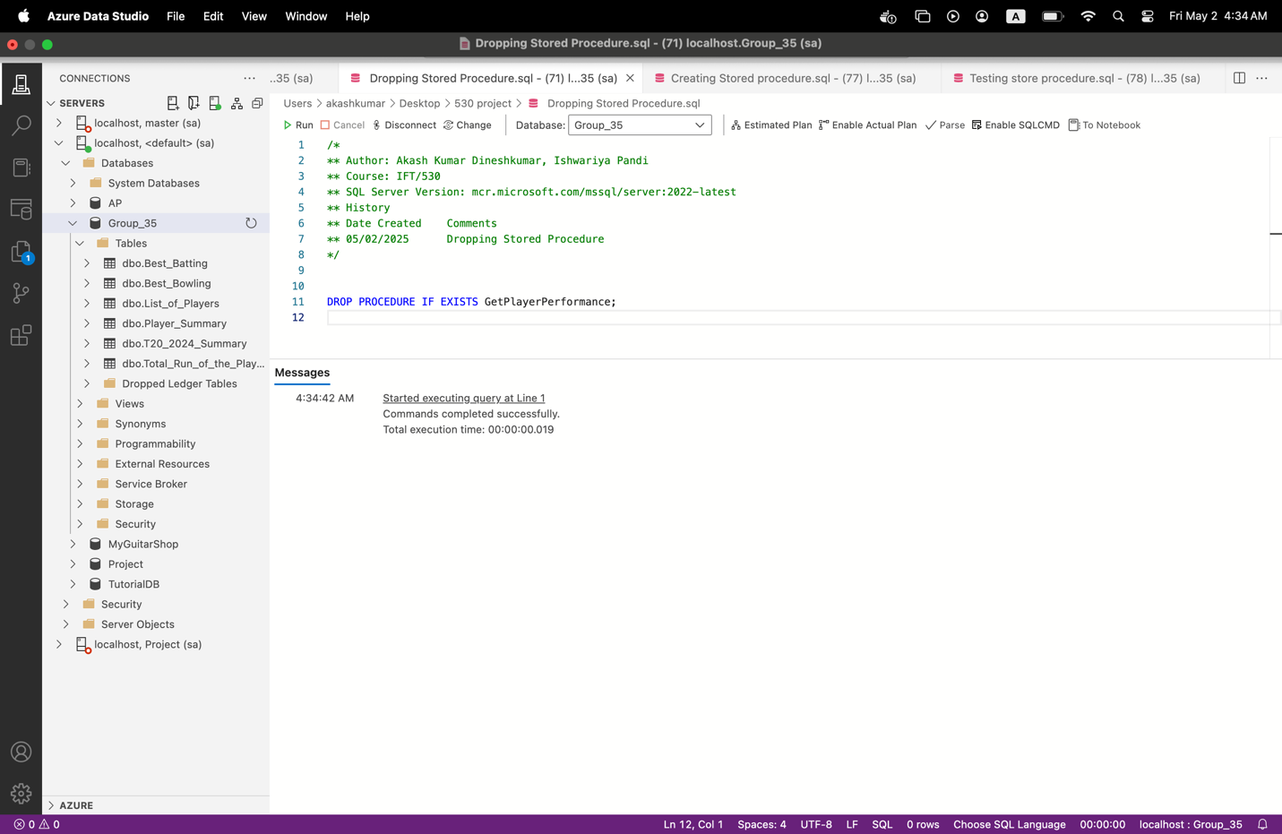

## **User Defined Function (UDF): fn_GetPlayerStrikeRate**

### **Purpose:** Return the **batting strike rate** of a player using data from Total_Run_of_the_Players.

**Create Script**

CREATE FUNCTION fn_GetPlayerStrikeRate (

@PlayerName VARCHAR(100)

)

RETURNS FLOAT

AS

BEGIN

DECLARE @StrikeRate FLOAT;

SELECT @StrikeRate = SR

FROM Total_Run_of_the_Players

WHERE Player = @PlayerName;

RETURN @StrikeRate;

END;

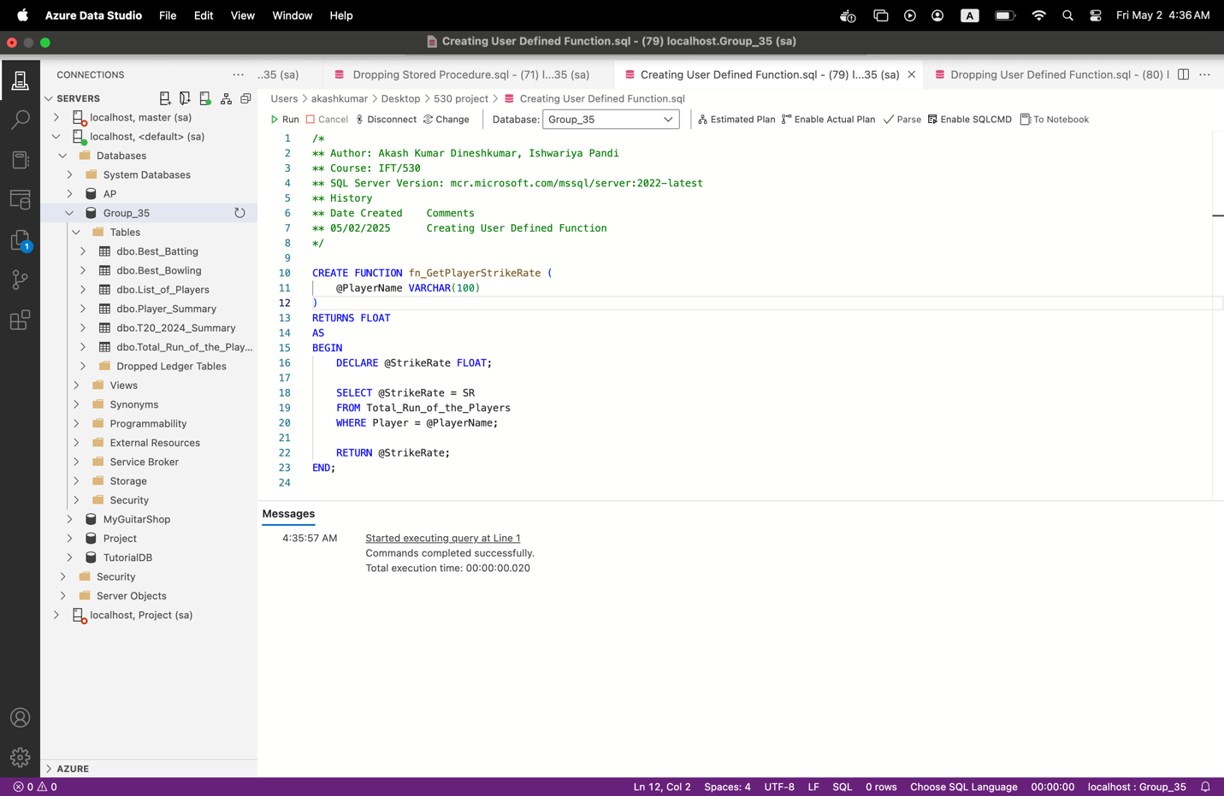

**Execution**

SELECT dbo.fn_GetPlayerStrikeRate('Virat Kohli') AS StrikeRate;

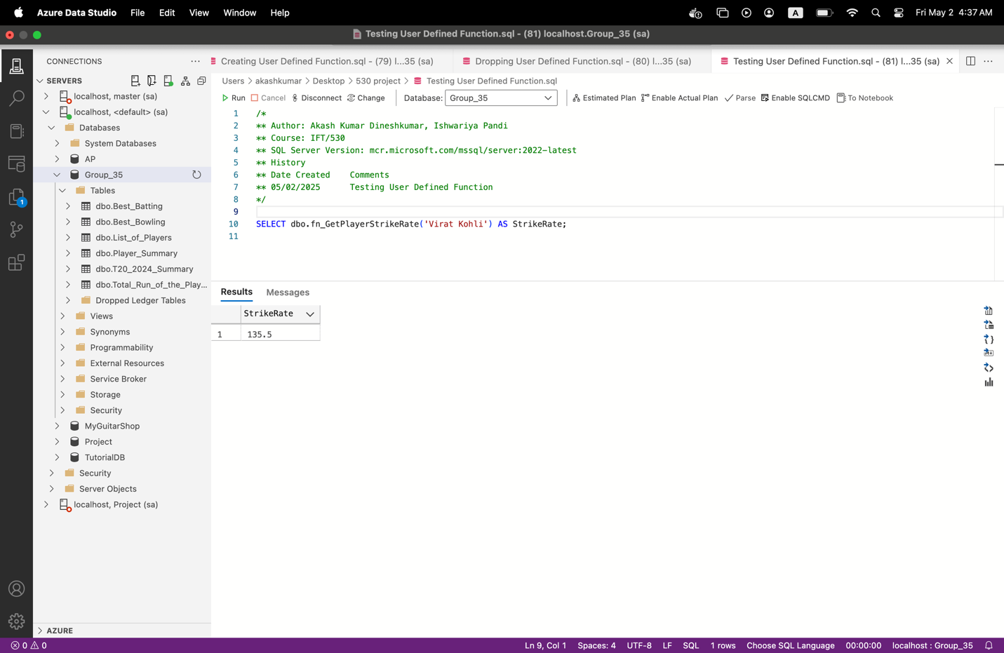

**Drop Script**

DROP FUNCTION IF EXISTS fn_GetPlayerStrikeRate;

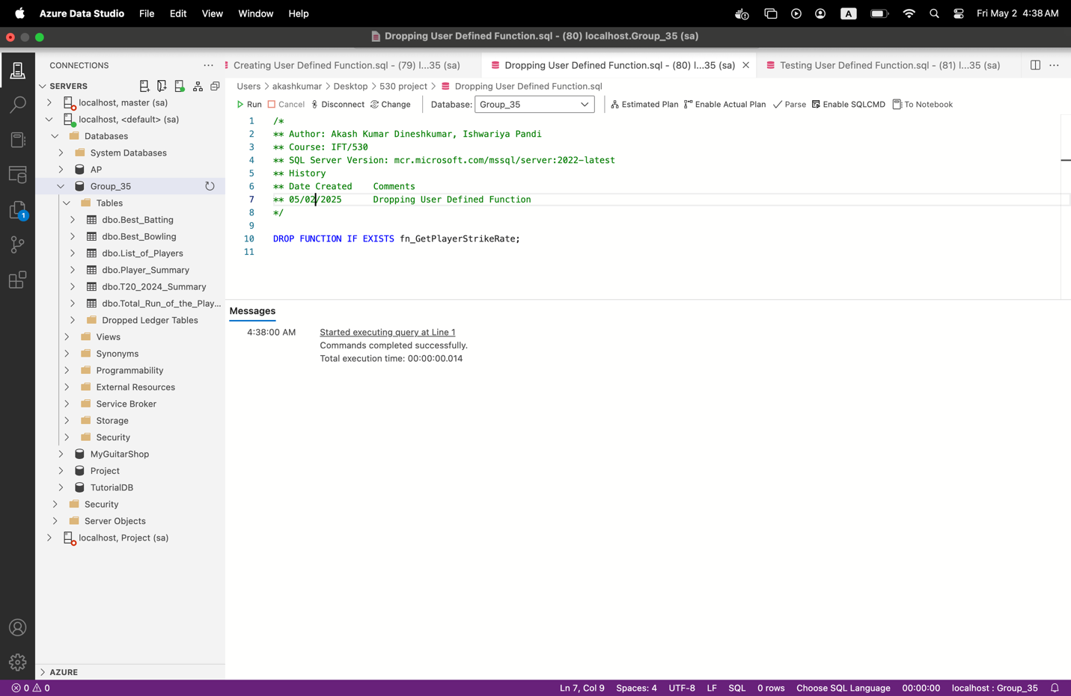

# **Create and Use a Cursor:**

**Cursor:**

Cursors are useful in scenarios where row-by-row processing is necessary—something that set-based SQL operations cannot handle efficiently. They allow a developer to iterate through each row in a result set and apply logic individually. This is particularly helpful in tasks like generating conditional alerts, performing batch updates, logging transactions, or applying custom rules to data in sequence. In the example provided, the cursor loops through each player's total runs and prints a message if a player has scored over 250 runs, effectively flagging top performers. This approach can be extended for real-world applications such as automated notifications, performance-based rewards, or live dashboard updates.

DECLARE @PlayerName VARCHAR(100)

DECLARE @TotalRuns INT

DECLARE cur_TopRunScorers CURSOR FOR

SELECT Player, Runs FROM Total_Run_of_the_Players;

OPEN cur_TopRunScorers;

FETCH NEXT FROM cur_TopRunScorers INTO @PlayerName, @TotalRuns;

WHILE @@FETCH_STATUS = 0

BEGIN

IF @TotalRuns > 250

BEGIN

PRINT @PlayerName + ' has scored over 250 runs! A Player of Interest!';

END

FETCH NEXT FROM cur_TopRunScorers INTO @PlayerName, @TotalRuns;

END

CLOSE cur_TopRunScorers;

DEALLOCATE cur_TopRunScorers;

